What is KMS?

AWS Key Management Service (KMS) is a managed service that helps you create, store, manage, and control cryptographic keys used to encrypt and decrypt data across AWS services.
How KMS Works
Application
|
Encrypt Request
|
AWS KMS
|
Generates Encryption Key
|
Encrypted Data
|
Stored in S3/RDS/EBS
When data is needed:
Application
|
Decrypt Request
|
AWS KMS
|
Verifies Permissions
|
Returns Plaintext Data

"Whenever an application wants to encrypt data, it sends a request to AWS KMS. KMS encrypts the data using its encryption keys, and the encrypted data is stored in AWS services like S3 or RDS. When the data is needed, KMS checks the user's permissions and decrypts the data only if the request is authorized."

Envelope Encryption
KMS uses Envelope Encryption for large amounts of data.
Instead of encrypting the entire file with the KMS key:
- KMS creates a Data Key.
- The Data Key encrypts the actual data.
- The Data Key itself is encrypted using the KMS Key.
- Both the encrypted data and encrypted data key are stored.
Customer Data
|
Data Key Encrypts Data
|
Encrypted Data
|
Encrypted Data Key
|
Stored Together
This approach is faster and more scalable because the KMS key doesn't directly encrypt large files.

Types of KMS Keys

1. AWS Owned Keys
Created and managed entirely by AWS. You cannot view or manage these keys.

2. AWS Managed Keys
Created automatically for a specific AWS service in your account. AWS manages the key, but you can view it in the KMS console and control some permissions.

3. Customer Managed Keys (CMKs)
You create and manage these keys. You control:
- IAM permissions
- Key rotation
- Key policy
- Aliases
- Enable/Disable
- Deletion schedule
Most organizations prefer Customer Managed Keys because they provide greater control.

AWS KMS Key Hierarchy
AWS Root of Trust
│
▼
HSM (Hardware Security Module)
│
▼
Customer Master Key (KMS Key)
(Now called Customer Managed Key)
│
Encrypts / Decrypts
Data Encryption Key (DEK)
│
Encrypts / Decrypts
Your Actual Data

What is AWS Lambda?
AWS Lambda is a serverless computing service that allows you to run code without provisioning or managing servers.
You simply:
- Write your code.
- Upload it to Lambda.
- Configure a trigger.
- Lambda automatically executes your code whenever the trigger occurs.
AWS takes care of:
- Server provisioning
- Scaling
- Operating system maintenance
- Patching
- High availability
- Fault tolerance
You only pay for the number of requests and the execution time.

Lambda Workflow
Customer Uploads File
│
▼
Amazon S3
│
▼
Trigger Lambda
│
▼
Run Python Code
│
▼
Store Result
│
▼
Amazon DynamoDB
Scenario: A user uploads a profile picture to an Amazon S3 bucket.
- The user uploads profile.jpg to Amazon S3.
- Amazon S3 generates an upload event.
- AWS Lambda is triggered automatically.
- Lambda receives the event details, including the bucket name and file name.
- Lambda resizes and compresses the image.
- The processed image is saved back to S3.
- Lambda writes execution logs to Amazon CloudWatch.
- The function completes, and the execution environment is shut down or kept warm for reuse.

What is AWS API Gateway?
AWS API Gateway is a fully managed AWS service that allows you to create, publish, secure, monitor, and manage APIs at any scale.
Think of API Gateway as a front door for your backend services. Instead of users directly accessing your application servers, all requests first go through API Gateway.
It supports backend services such as:
- AWS Lambda
- EC2 instances
- Containers (ECS/EKS)
- Application Load Balancer (ALB)
- Any HTTP endpoint
- Other AWS services

API Gateway Workflow
- A client sends an HTTP or HTTPS request to API Gateway.
- API Gateway receives the request.
- API Gateway authenticates the user if authentication is enabled.
- API Gateway validates the request.
- API Gateway applies rate limits or throttling if configured.
- API Gateway forwards the request to the backend service.
- The backend processes the request.
- The backend returns the response to API Gateway.
- API Gateway can transform or modify the response if needed.
- API Gateway sends the final response back to the client.

Types of APIs

1. REST API
Traditional REST-based APIs.
Features:
- API keys
- Request validation
- Usage plans
- Caching
- Custom authorizers
- Fine-grained features
Best for enterprise applications.

2. HTTP API
Simpler and lower-cost APIs.
Features:
- Faster
- Lower latency
- Lower cost
- JWT authentication
- Lambda integration
- OIDC support
Best for modern web and mobile applications.

3. WebSocket API
Used for two-way communication.
Example:
- Chat applications
- Live notifications
- Gaming
- Stock market updates

Task 1: Create and Configure AWS KMS

Objective
Create and manage a Customer Managed KMS Key with proper security settings.

Activities
- Create a Customer Managed KMS Key.
- Assign Key Administrators and Key Users.
- Create an alias for the key.
- Enable automatic key rotation.
- Create an IAM policy to allow Encrypt, Decrypt, GenerateDataKey, and DescribeKey operations while denying key deletion.
- Disable and re-enable the KMS key to observe its behavior.
- Schedule key deletion and cancel it before the waiting period ends.
Prerequisites
Before starting, ensure you have:
- AWS Account
- IAM user with permissions for:
  - AWS KMS
  - IAM
  - CloudTrail (optional)
- AWS Management Console access
- Region selected (recommended: us-east-1)
- Basic understanding of IAM policies

Implementation Steps

Step 1: Create a Customer Managed Key (CMK)
- Open AWS Console.
- Go to KMS.
- Click Create Key.
- Select:
  - Key type → Symmetric
  - Key usage → Encrypt and Decrypt
- Click Next.
- Give the key a name.
- Continue.
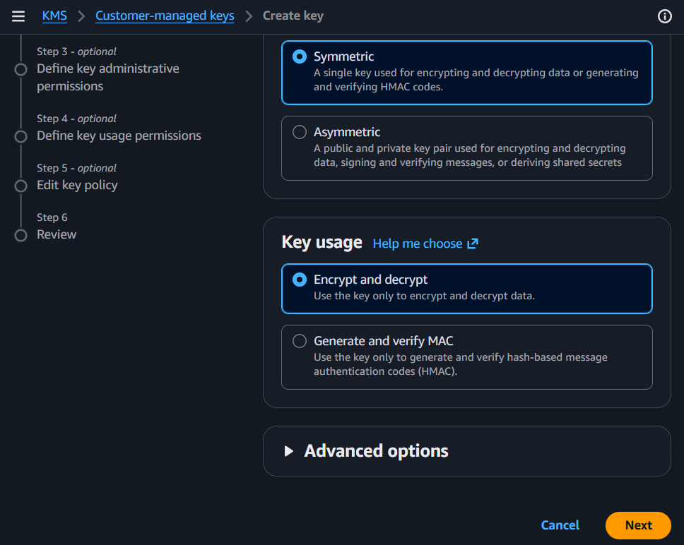
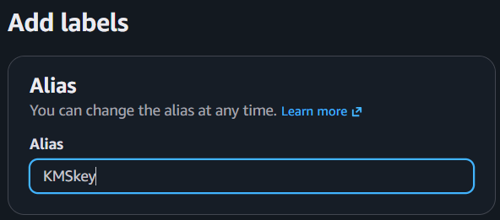

Step 2: Assign Key Administrators
Select IAM users or roles who can:
- Edit the key
- Enable/Disable
- Rotate
- Delete
- Manage permissions
Click Next.
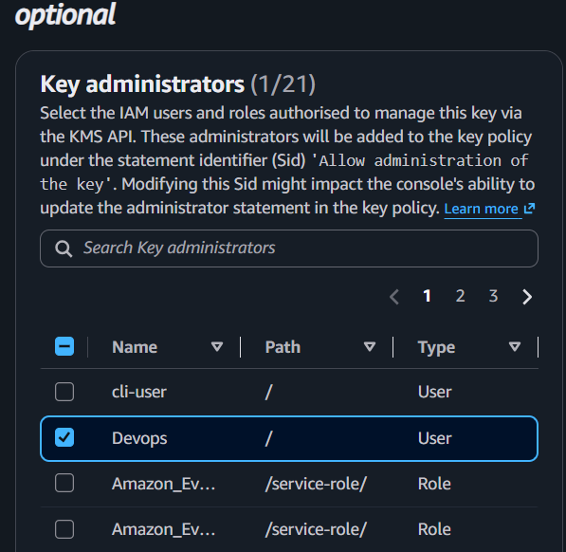

Step 3: Assign Key Users
Choose IAM users/roles allowed to:
- Encrypt
- Decrypt
- GenerateDataKey
- DescribeKey
Click Next.
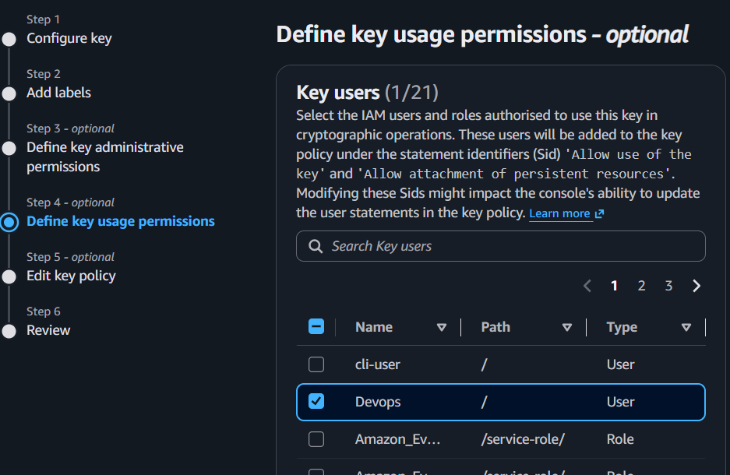

Step 4: Review and Create
Review the configuration.
Click Finish.
The CMK is created.
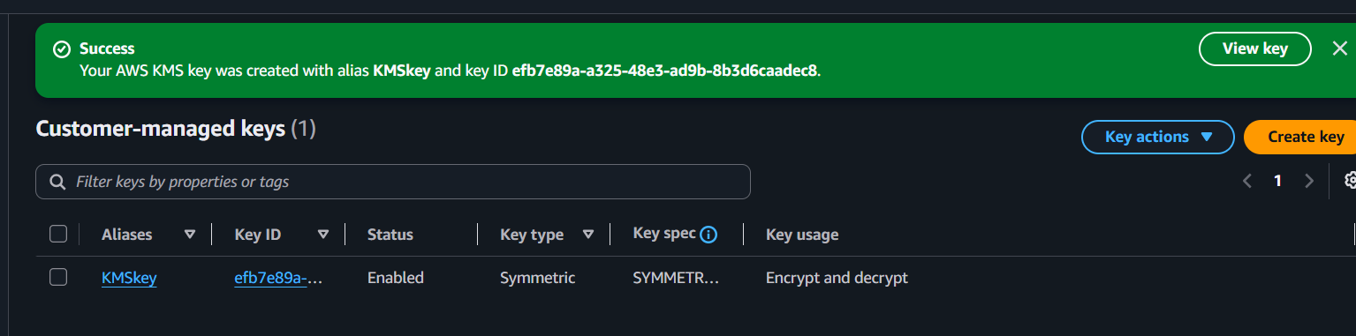

Step 5: Create an Alias
- Open the created key.
- Choose Aliases.
- Click Create Alias.
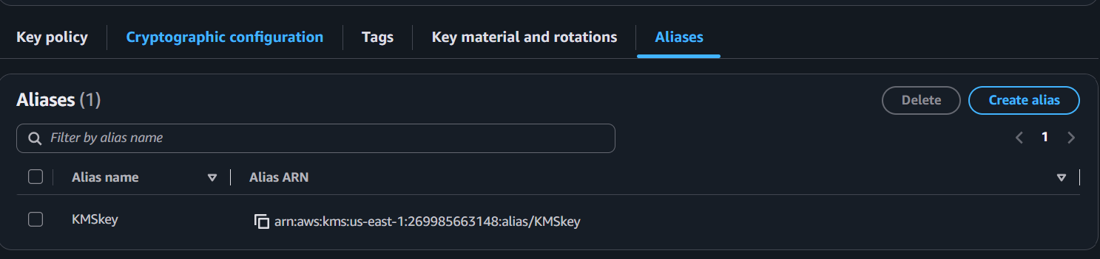
- Example:
alias/devops-kms
Save. 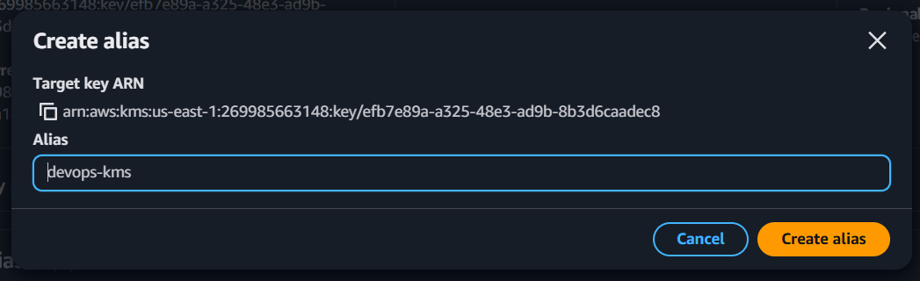
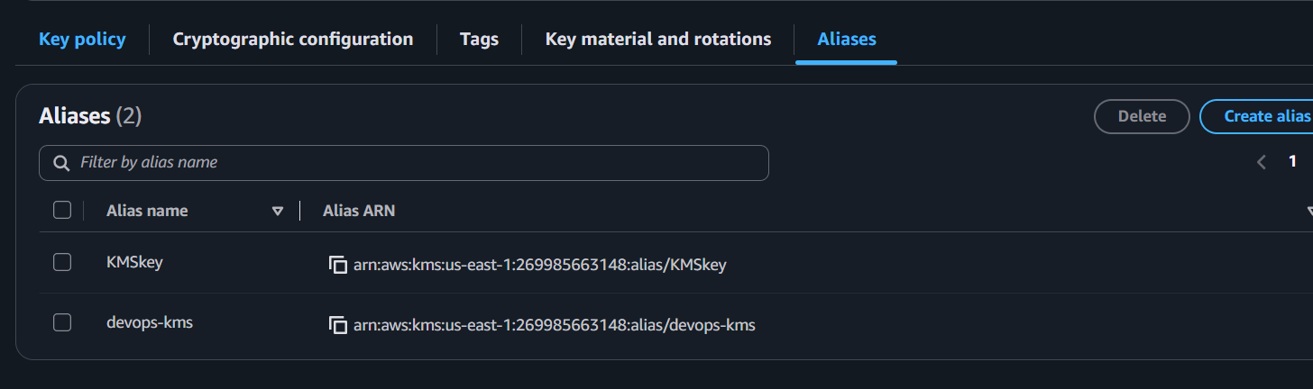

Step 6: Enable Automatic Rotation
Inside the key:
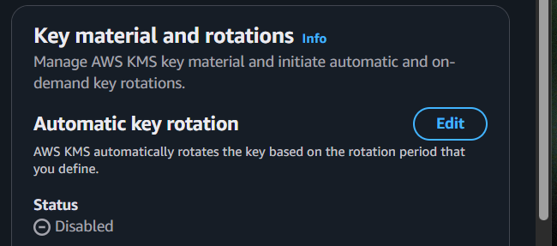
Enable
Automatic Key Rotation
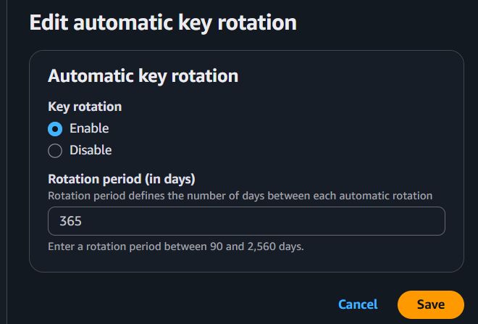
Save.
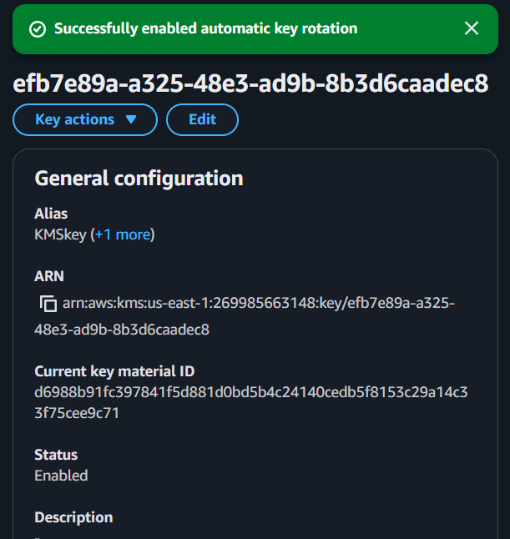

Step 7: Create IAM Policy
Create a custom IAM policy allowing:
- kms:Encrypt
- kms:Decrypt
- kms:GenerateDataKey
- kms:DescribeKey
Explicitly deny:
- kms:ScheduleKeyDeletion
Attach the policy to an IAM user or role.
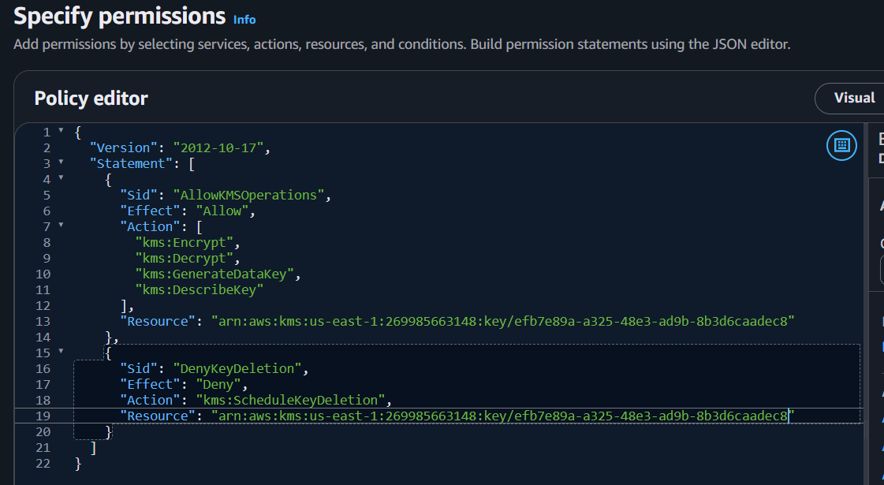

Step 8: Disable the Key
Open the key.
Choose
Disable
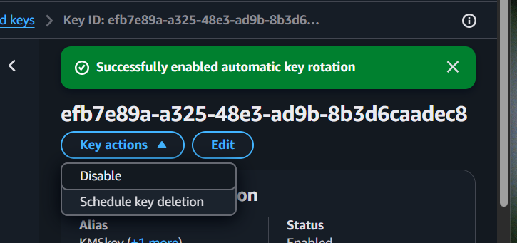
Confirm.
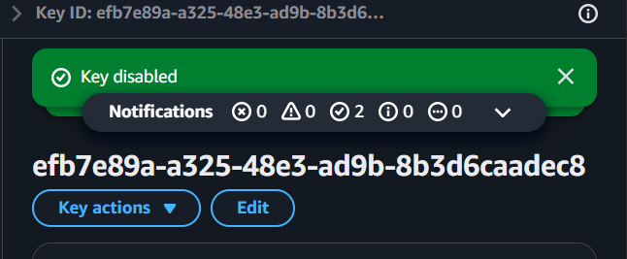

Step 9: Test Disabled Key
Attempt encryption using:
- S3
- CLI
- Secrets Manager
AWS should return an error because the key is disabled.

Step 10: Re-enable the Key
Select
Enable
The key becomes usable again.
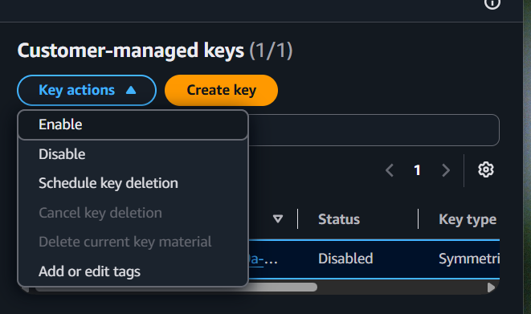

Step 11: Schedule Key Deletion
Choose
Schedule deletion
Select:
Waiting period:
7 days
Confirm.
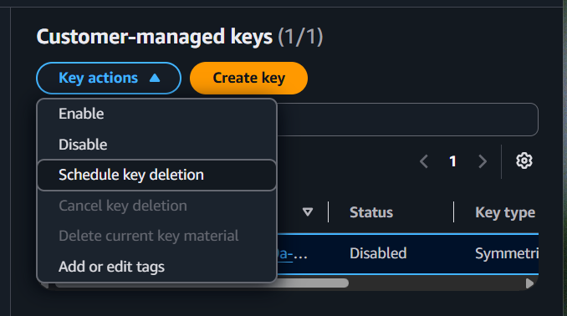
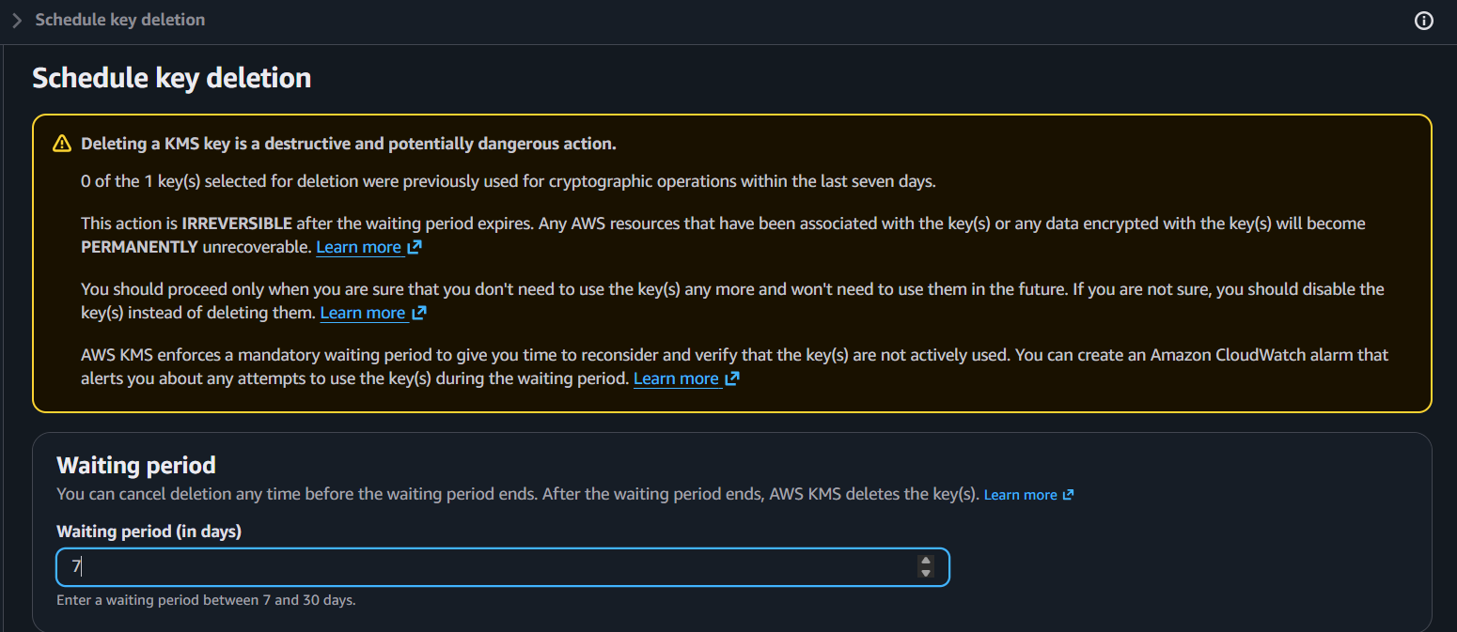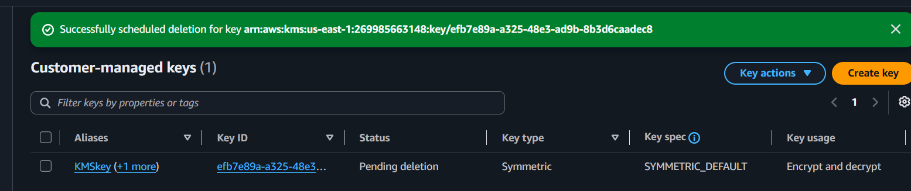

Step 12: Cancel Deletion
Before 7 days expire:
Choose
Cancel key deletion
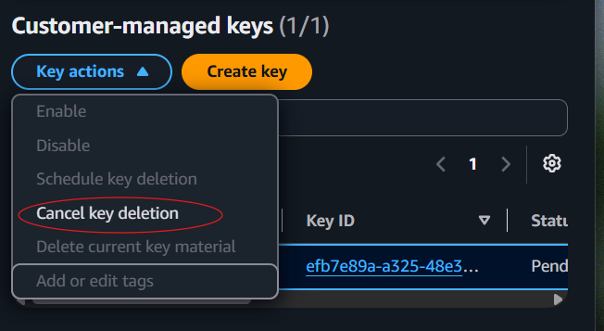
The key returns to active status.
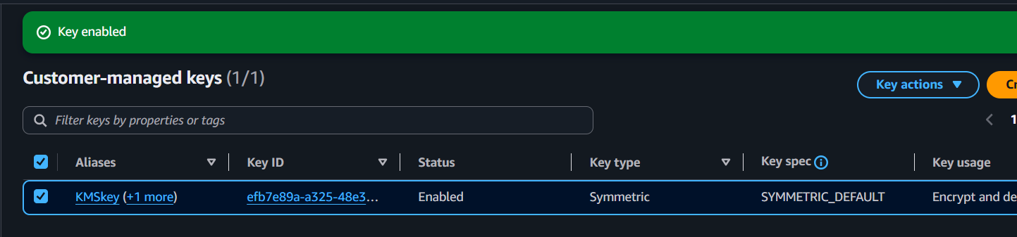

Expected Outcome
After completing Task 1, you should have:
✅ Customer Managed Key created
✅ Alias assigned
✅ Key administrators configured
✅ Key users configured
✅ Automatic rotation enabled
✅ IAM policy created
✅ Successfully disabled and enabled the key
✅ Scheduled deletion
✅ Cancelled deletion before expiration

Task 2: Integrate AWS KMS with AWS Services

Objective
Use a single Customer Managed KMS Key to encrypt multiple AWS services.

Activities
- Create an S3 bucket and enable default encryption using the KMS key.
- Launch an EC2 instance with an encrypted EBS volume.
- Create an encrypted RDS (MySQL/MariaDB) instance using the same KMS key.
- Store a database password in AWS Secrets Manager using the same KMS key.
- Create a SecureString parameter in Systems Manager Parameter Store using the same KMS key.
- Verify that all services are using the same Customer Managed KMS Key.

Prerequisites
- ✅ Create and manage a Customer Managed KMS Key
- ✅ Customer Managed KMS Key is in Enabled state.
- ✅ IAM user has permissions for EC2, S3, RDS, KMS, Secrets Manager, and Systems Manager.
- ✅ Region is the same as the KMS key (for example, us-east-1).
- ✅ VPC and Security Group are available.
- ✅ EC2 Key Pair is available.

Step 1: Create an S3 Bucket and Enable Default Encryption Using the KMS Key

Purpose
Create an S3 bucket where every uploaded object is automatically encrypted using your Customer Managed KMS Key.

Navigation
AWS Console
↓
Amazon S3
↓
Buckets
↓
Create bucket

Detailed Procedure

1. Open Amazon S3
- Log in to the AWS Management Console.
- Search for S3.
- Open Amazon S3.

2. Create a Bucket
Click Create bucket.
Configure:
Setting | Value
Bucket Name | nikhil-kms-demo-2026 (must be globally unique)
AWS Region | Same region as KMS key (e.g., us-east-1)
Object Ownership | ACLs disabled (default)
Block Public Access | Keep enabled
Click Next
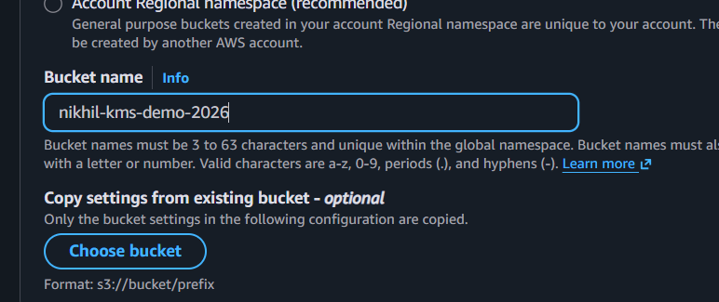

3. Enable Default Encryption
Locate the Default encryption section.
Configure:
Setting | Value
Server-side encryption | AWS Key Management Service (AWS KMS)
KMS Key Type | Customer managed keys
KMS Key | Select the KMS key you created in Task 1
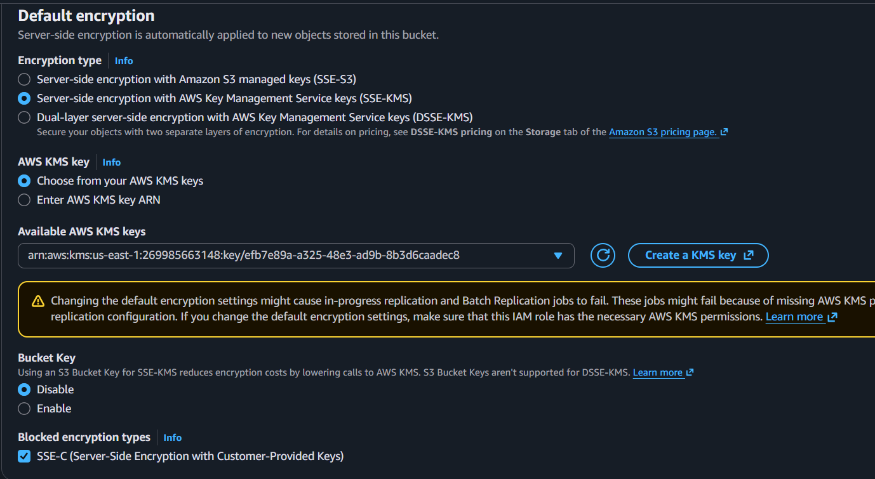

4. Create the Bucket
Review the settings.
Click Create bucket.
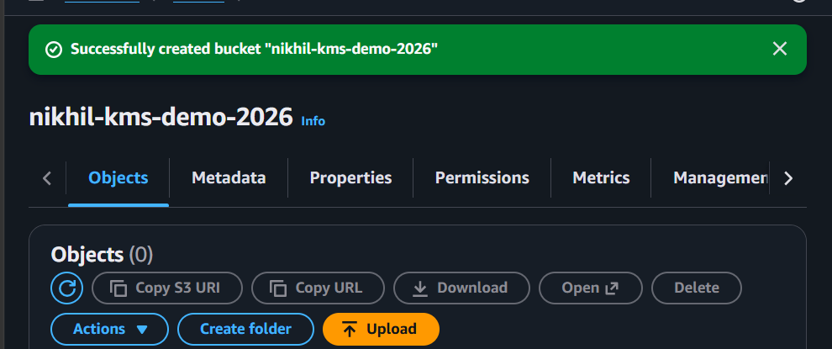

Why We Do This

Normally, S3 stores uploaded objects without using your own KMS key.

5. Verification

Verify Default Encryption
- Open the bucket you just created.
- Go to the Properties tab.
- Scroll to Default encryption.
Verify:
Property | Expected Value
Encryption Type | AWS KMS (SSE-KMS)
KMS Key | Your Customer Managed KMS Key
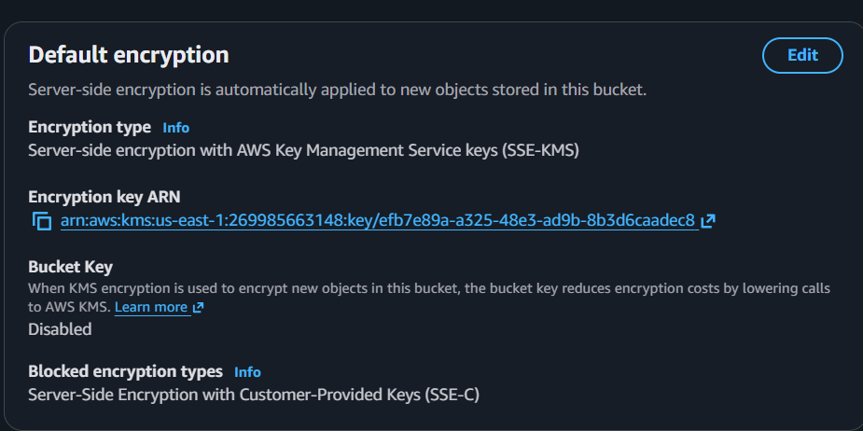
By enabling Default Encryption with a Customer Managed KMS Key:
- Every object uploaded to the bucket is automatically encrypted.
- AWS uses your KMS key to generate a unique data key for each object.
- You have centralized control over encryption through AWS KMS.

Verification
- Open the bucket.
- Upload a sample file (for example, sample.txt).
- After the upload completes, click the uploaded object.
- Open the Properties tab.
- Scroll to Server-side encryption settings.
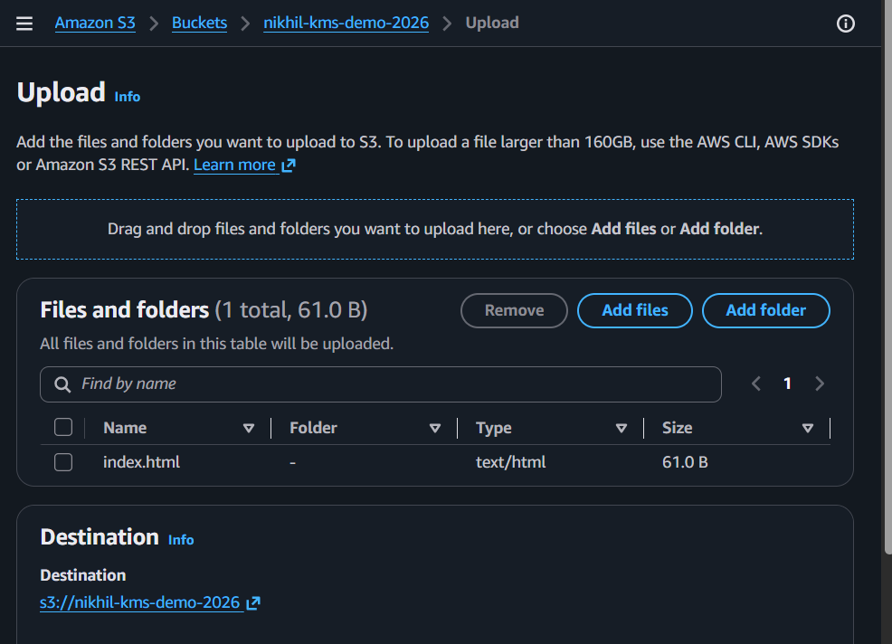
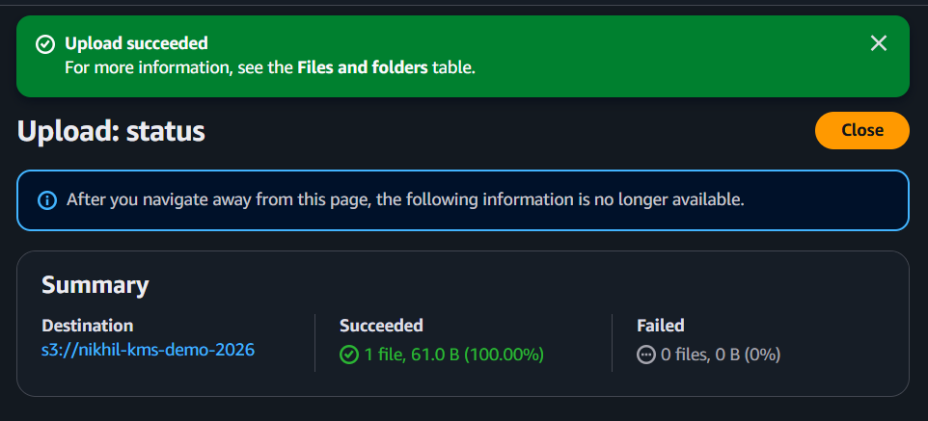
Verify:
Property | Expected Value
Encryption | AWS KMS
KMS Key | Your Customer Managed KMS Key (alias/kms-lab-key)

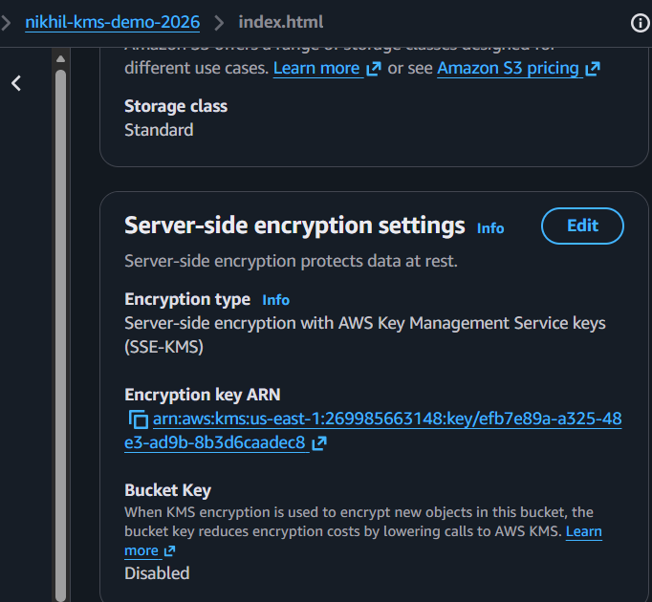

Expected Outcome
- ✅ S3 bucket created successfully.
- ✅ Default encryption enabled.
- ✅ Customer Managed KMS Key selected.
- ✅ Uploaded objects are automatically encrypted with the same KMS key.

Step 2: Launch an EC2 Instance with an Encrypted EBS Volume

Purpose
Launch an EC2 instance where the root EBS volume is encrypted using the same Customer Managed KMS Key created in Task 1.

Navigation
AWS Console
↓
EC2
↓
Instances
↓
Launch instances

Detailed Procedure

1. Open EC2
- Log in using your IAM user.
- Search for EC2.
- Open Amazon EC2.
- Click Launch instances.

2. Configure the Instance
Enter the following:
Setting | Value
Name | KMS-EC2-Instance

3. Choose an AMI
Select:
Amazon Linux 2023
or
Amazon Linux 2
Either is fine.

4. Choose Instance Type
Select:
t3.micro

5. Select Key Pair
Choose your existing key pair.
Example:
devops.pem
(Use the key pair you've been using in your previous labs.)

6. Configure Network Settings
Choose:
Setting | Value
VPC | Your existing VPC
Subnet | Public Subnet
Auto Assign Public IP | Enable
Security Group | Existing Security Group (kms-lab-sg or your existing SG)

7. Configure Storage
This is the most important step.
Under Configure storage:
Click the Edit (or pencil) icon if necessary.
Configure:
Setting | Value
Volume Type | gp3
Size | 8 GiB (default is fine)
Encrypted | ✅ Enable
KMS Key | Customer Managed Key
Select Key | Your KMS Key (alias/kms-lab-key)
It should look similar to:
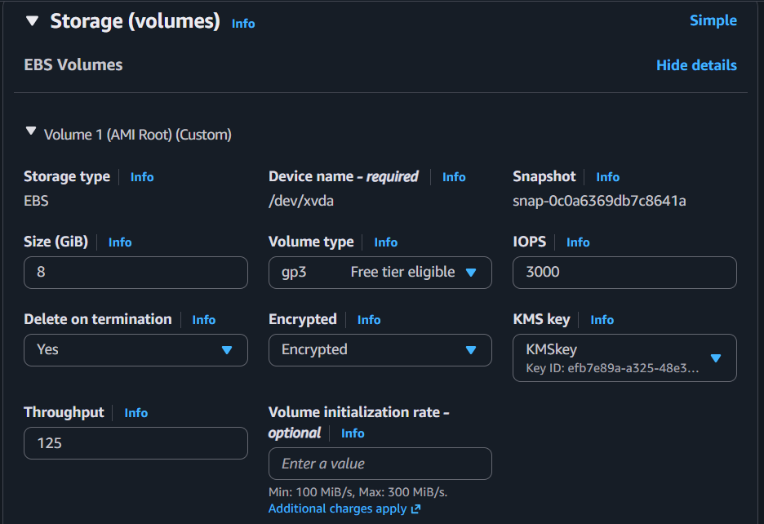
Encrypted : Yes

KMS Key :
alias/kms-lab-key
Important: If Encrypted is already checked but the KMS key is aws/ebs, change it to your Customer Managed KMS Key.

8. Review Configuration
Verify:
- Amazon Linux AMI
- t3.micro
- Existing Key Pair
- Public Subnet
- Existing Security Group
- Encrypted EBS Volume
- Customer Managed KMS Key selected
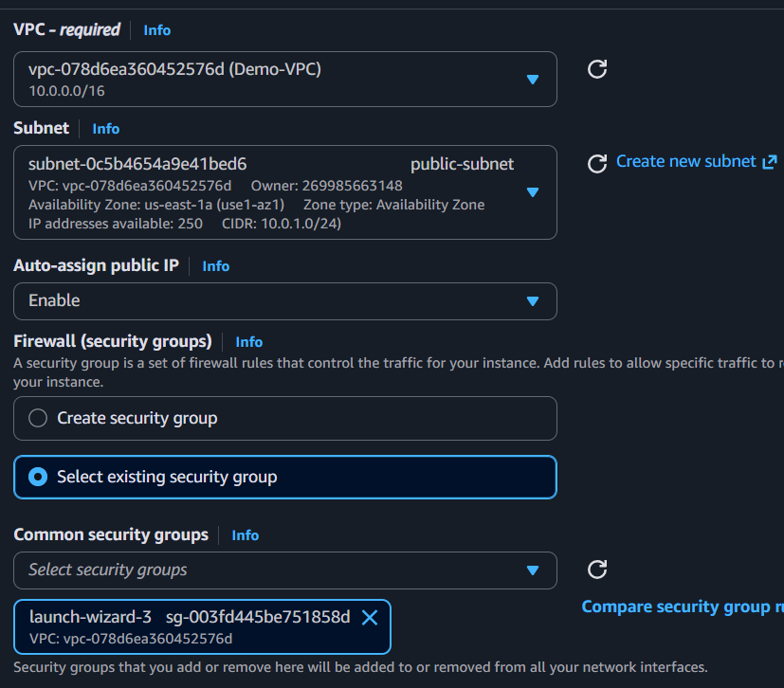

9. Launch Instance
Click:
Launch instance
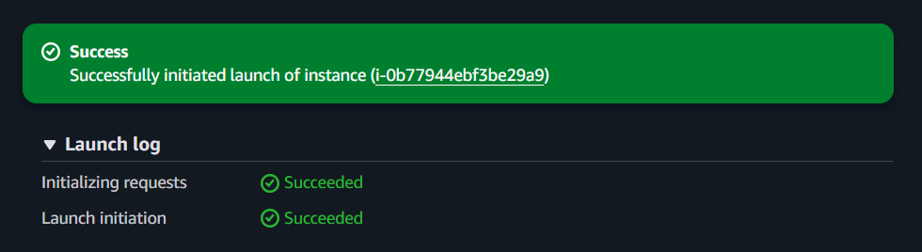
Wait until the instance reaches:
Running
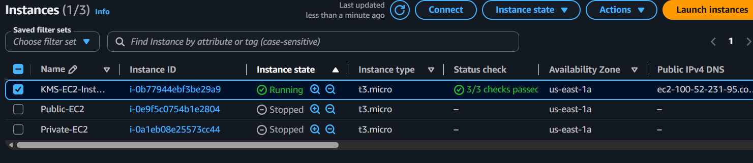

Verification

Verify EBS Encryption
Go to:
EC2
↓
Elastic Block Store
↓
Volumes
Select the volume attached to your instance.
Verify:
Property | Expected Value
Encrypted | Yes
KMS Key | Your Customer Managed KMS Key

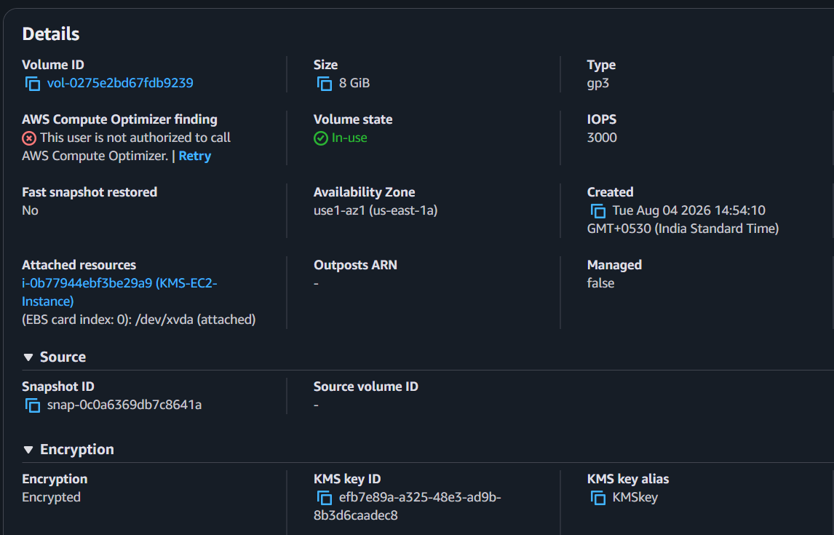

Why We Do This
Amazon EBS stores data on disk.
By enabling encryption with a Customer Managed KMS Key:
- Data stored on the volume is encrypted at rest.
- Snapshots created from the volume are also encrypted.
- You control access to the encryption key.
- The same KMS key is now used by both S3 and EBS.

Expected Outcome
After completing this step:
- ✅ EC2 instance launched successfully.
- ✅ Root EBS volume is encrypted.
- ✅ Encryption uses the same Customer Managed KMS Key created in Task 1.
- ✅ Instance is in the Running state.

Step 3: Create an Encrypted RDS (MariaDB/MySQL) Instance Using the Same Customer Managed KMS Key

Purpose
Create an Amazon RDS database where the database storage is encrypted using the same Customer Managed KMS Key created in Task 1.

Navigation
AWS Console
↓
Amazon RDS
↓
Databases
↓
Create database

Detailed Procedure

1. Open Amazon RDS
- Log in using your IAM user.
- Search for RDS.
- Open Amazon RDS.
- Click Create database.

2. Choose Database Creation Method
Select:
Setting | Value
Creation method | Standard Create
Click Next (if prompted).

3. Select Database Engine
Since you've already worked with MariaDB, we'll continue with it.
Choose:
Setting | Value
Engine | MariaDB

4. Select Engine Version
Choose the latest available version (or the default version AWS selects).
Example:
MariaDB 10.11.x
(The version may differ in your account.)

5. Templates
Choose:
Free Tier
or
Dev/Test
depending on what is available.

6. Configure Database Settings
Example:
Setting | Value
DB Instance Identifier | kms-mariadb
Master Username | admin
Master Password | Create your own password
Confirm Password | Same password
Save the password. You'll need it later.

7. Instance Configuration
Choose:
Setting | Value
DB Instance Class | db.t3.micro

8. Storage Configuration
Keep the defaults:
Setting | Value
Storage Type | gp3
Allocated Storage | 20 GB

9. Enable Storage Encryption (Most Important Step)
Scroll down to:
Storage Encryption
Configure:
Setting | Value
Enable Encryption | ✅ Checked
KMS Key | Select your Customer Managed KMS Key
For example:
KMSkey
Do not select:
alias/aws/rds
because that is the AWS-managed key.

10. Connectivity
Choose:
Setting | Value
VPC | Same VPC used for EC2
Public Access | No (recommended)
Security Group | Existing Security Group or create a new one for RDS
Availability Zone | No preference

11. Database Authentication
Leave the default:
Password Authentication

12. Additional Configuration
Leave everything else as the default.

13. Create the Database
Click:
Create database
Wait until the status changes to:
Available
This may take 10–20 minutes.
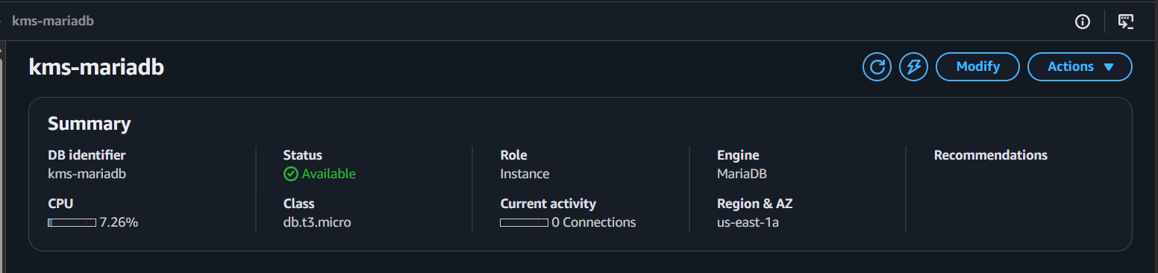

Verification
After the database is available:
Go to:
Amazon RDS
↓
Databases
↓
kms-mariadb
Scroll to the Configuration section.
Verify:
Property | Expected Value
Storage Encrypted | Yes
KMS Key | Your Customer Managed KMS Key (KMSkey)

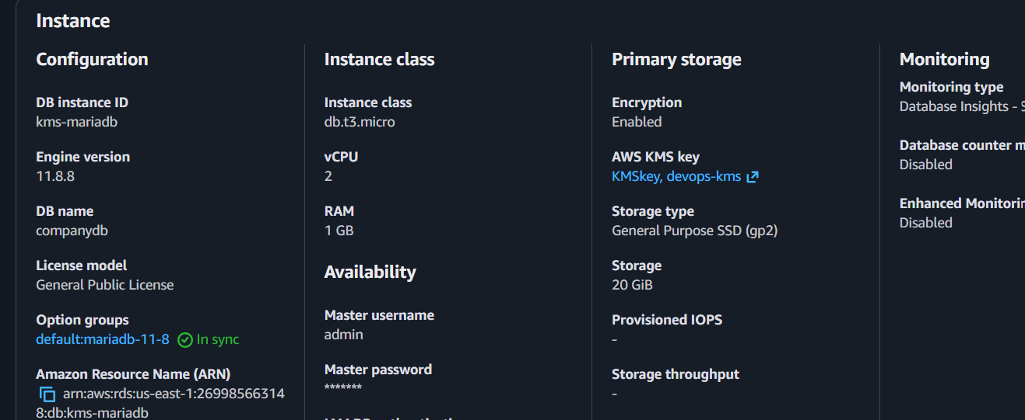

Why We Do This
Amazon RDS encrypts:
- Database storage
- Automated backups
- Read replicas
- Snapshots
Using your Customer Managed KMS Key means:
- You control who can use the key.
- All database encryption is centrally managed through KMS.
- You can audit key usage with CloudTrail.

Expected Outcome
After completing this step:
- ✅ MariaDB RDS instance created.
- ✅ Storage encryption enabled.
- ✅ Customer Managed KMS Key selected.
- ✅ Database status is Available.
- ✅ RDS storage is encrypted using the same KMS key as your S3 bucket and EBS volume.

Step 4: Store a Database Password in AWS Secrets Manager Using the Same Customer Managed KMS Key

Purpose
Store your MariaDB database password securely in AWS Secrets Manager and encrypt it using the same Customer Managed KMS Key (KMSkey).
Instead of hardcoding passwords in applications, applications can retrieve them securely from Secrets Manager.

Navigation
AWS Console
↓
AWS Secrets Manager
↓
Secrets
↓
Store a new secret

Detailed Procedure

1. Open AWS Secrets Manager
- Log in using your IAM user.
- Search for Secrets Manager.
- Open AWS Secrets Manager.
- Click Store a new secret.

2. Choose Secret Type
Select:
Credentials for Amazon RDS database

3. Enter Database Credentials
Enter the same credentials you used while creating the RDS instance.
Setting | Value
User name | admin
Password | Your RDS master password

4. Select the Database
Choose:
Setting | Value
Database | kms-mariadb
If your database does not appear, you can choose Other type of secret and manually create the secret with key/value pairs.

5. Encryption Key (Most Important Step)
Locate:
Encryption key
Choose:
Customer managed key
Then select:
KMSkey
Do NOT select:
aws/secretsmanager
because the task requires using the same Customer Managed KMS Key.

6. Secret Name
Enter:
Setting | Value
Secret Name | kms-rds-secret
(Optional)
Description:
Stores MariaDB credentials encrypted using KMSkey
Click Next.

7. Rotation
For this lab:
Choose:
Disable automatic rotation
Click Next.

8. Review
Verify:
- Username = admin
- Correct password
- Encryption Key = KMSkey
- Secret Name = kms-rds-secret
Click:
Store
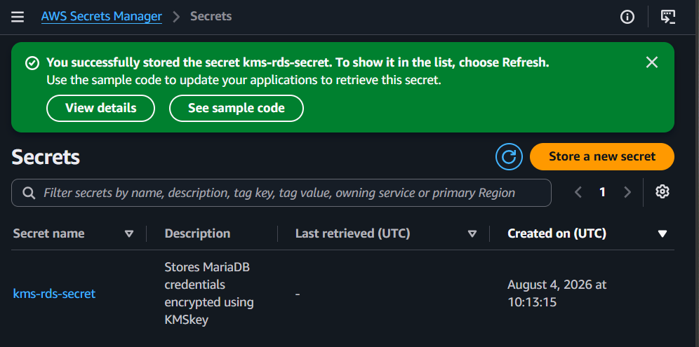

Verification
Open:
Secrets Manager
↓
Secrets
↓
kms-rds-secret
Verify:
Property | Expected Value
Secret Name | kms-rds-secret
Encryption Key | KMSkey
Status | Active
Click Retrieve secret value and confirm the stored username and password are correct.
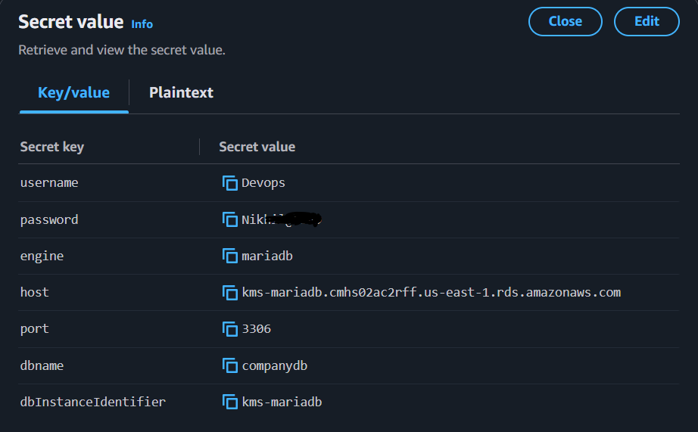

Why We Do This
Instead of storing passwords in:
- Application code
- Configuration files
- Shell scripts
we store them securely in AWS Secrets Manager.
Benefits include:
- Secure storage
- Encryption with AWS KMS
- Fine-grained IAM access control
- Optional automatic password rotation
- Easy integration with applications and Lambda

Expected Outcome
After completing this step:
- ✅ Secret created successfully.
- ✅ Secret contains your RDS username and password.
- ✅ Secret is encrypted using KMSkey.
- ✅ Applications can securely retrieve the credentials without exposing the password.

Step 5: Create a SecureString Parameter in Systems Manager Parameter Store Using the Same Customer Managed KMS Key

Purpose
Store a sensitive value (such as a database password) in AWS Systems Manager Parameter Store as a SecureString, encrypted with the same Customer Managed KMS Key (KMSkey).
Unlike Secrets Manager, Parameter Store is commonly used for storing configuration values and secrets that don't require automatic rotation.

Navigation
AWS Console
↓
Systems Manager
↓
Application Management
↓
Parameter Store
↓
Create parameter

Detailed Procedure

1. Open Systems Manager
- Sign in using your IAM user.
- Search for Systems Manager.
- Open AWS Systems Manager.
- In the left navigation pane, click Parameter Store.
- Click Create parameter.

2. Configure Parameter Details
Enter the following:
Setting | Value
Name | /database/password
Description | MariaDB password encrypted using KMSkey (optional)
Tier | Standard

3. Select Parameter Type
Choose:
SecureString
This ensures the value is encrypted.

4. Select the KMS Key (Most Important Step)
In the KMS key source or KMS Key section:
Choose:
Customer managed key
Then select:
KMSkey
Do NOT select:
alias/aws/ssm
because the task requires using the same Customer Managed KMS Key.

5. Enter the Parameter Value
In the Value field, enter your RDS password.
Example:
MySecurePassword@123
Use the same password you created for your MariaDB RDS instance.

6. Review
Verify:
Setting | Expected Value
Name | /database/password
Type | SecureString
KMS Key | KMSkey
Tier | Standard

7. Create the Parameter
Click:
Create parameter
Wait for the success message.
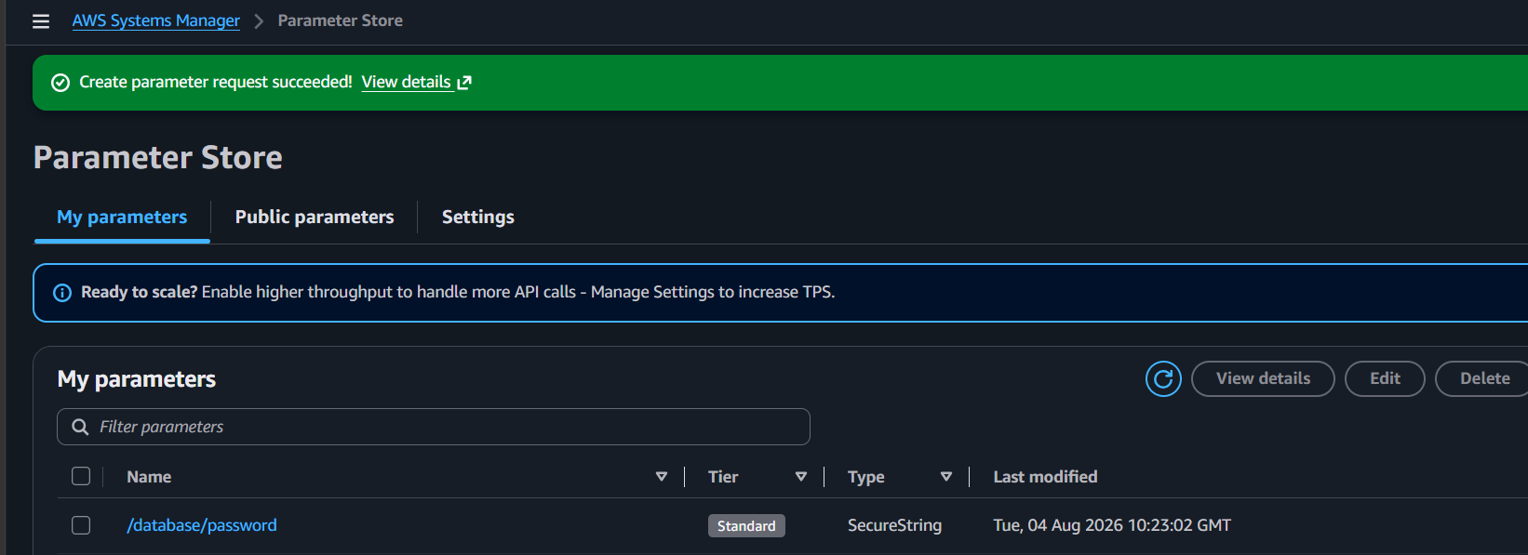

Verification
Go to:
Systems Manager
↓
Parameter Store
Open:
/ database / password
Verify:
Property | Expected Value
Type | SecureString
KMS Key | KMSkey
Tier | Standard
The value will be encrypted and not displayed in plain text by default.
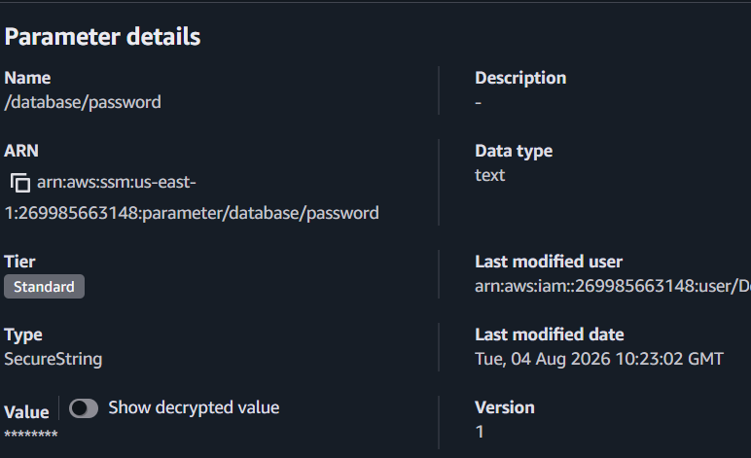

Why We Do This
Parameter Store is used to securely store:
- Database passwords
- API keys
- Application configuration
- Environment variables
Using a Customer Managed KMS Key provides:
- Centralized encryption management.
- IAM-based access control.
- CloudTrail logging for key usage.
- Consistent encryption across AWS services.

Expected Outcome
After completing this step:
- ✅ SecureString parameter created.
- ✅ Parameter encrypted using KMSkey.
- ✅ Parameter stored securely in Systems Manager.
- ✅ Applications can retrieve the parameter securely using IAM permissions.

Step 6: Verify That All AWS Services Are Using the Same Customer Managed KMS Key

Purpose
Verify that all the AWS services configured in Task 2 are using the same Customer Managed KMS Key (KMSkey) for encryption.
This confirms that centralized encryption is working correctly across multiple AWS services.

Services to Verify
You need to verify the following services:
- ✅ Amazon S3
- ✅ Amazon EC2 (EBS Volume)
- ✅ Amazon RDS
- ✅ AWS Secrets Manager
- ✅ AWS Systems Manager Parameter Store

Part 1: Verify Amazon S3

Navigation
AWS Console
↓
Amazon S3
↓
Your Bucket
↓
Properties

Procedure
- Open Amazon S3.
- Select the bucket created in Step 1.
- Click Properties.
- Scroll to Default encryption.
Verify:
Property | Expected Value
Encryption Type | AWS KMS (SSE-KMS)
KMS Key | KMSkey

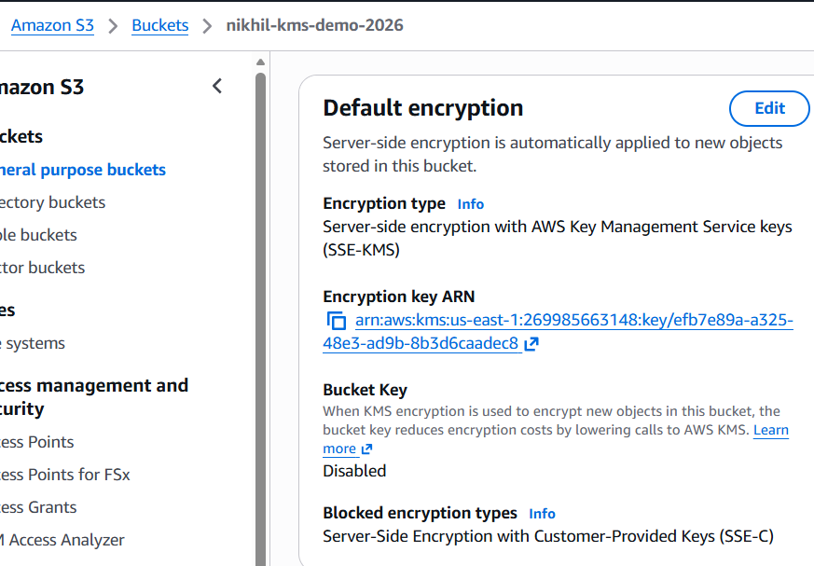

Verify Uploaded Object
- Open the bucket.
- Click the uploaded file.
- Open the Properties tab.
- Scroll to Server-side encryption settings.
Verify:
Property | Expected Value
Encryption | AWS KMS
KMS Key | KMSkey

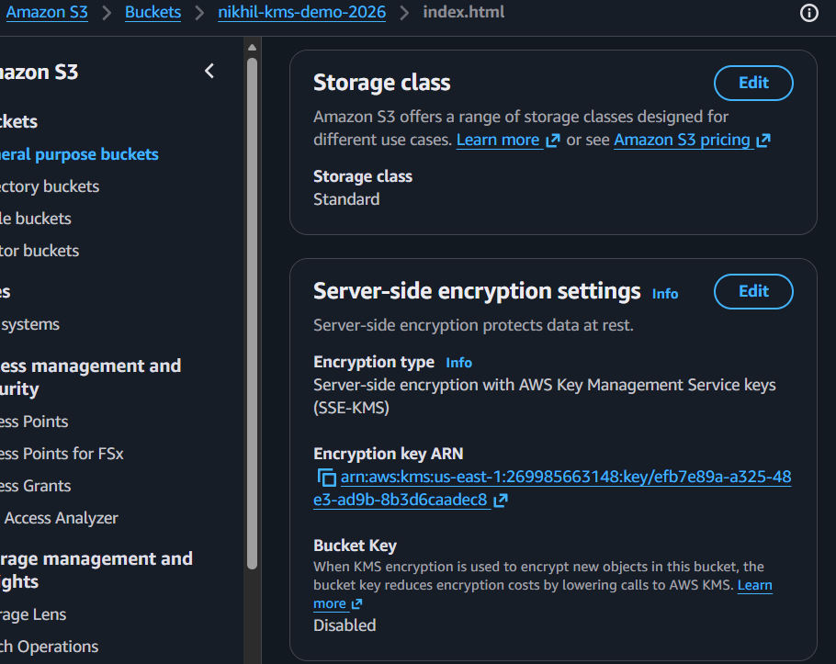

Part 2: Verify EC2 EBS Volume

Navigation
AWS Console
↓
EC2
↓
Volumes

Procedure
- Open EC2.
- Click Volumes.
- Select the root EBS volume attached to KMS-EC2-Instance.
Verify:
Property | Expected Value
Encryption | Encrypted
KMS Key Alias | KMSkey
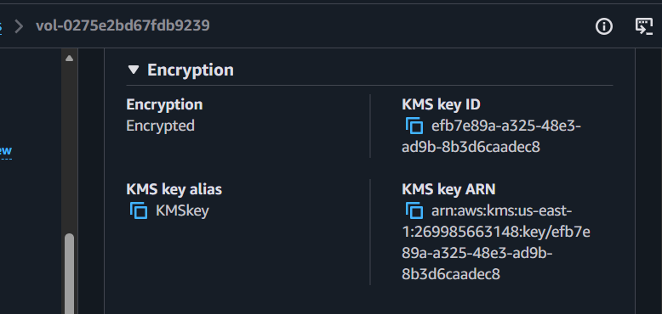

Part 3: Verify Amazon RDS

Navigation
AWS Console
↓
Amazon RDS
↓
Databases
↓
kms-mariadb

Procedure
- Open your RDS instance.
- Go to the Configuration tab.
Verify:
Property | Expected Value
Storage Encryption | Enabled
KMS Key | KMSkey

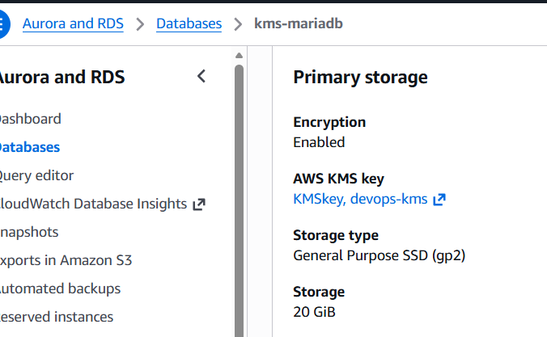

Part 4: Verify AWS Secrets Manager

Navigation
AWS Console
↓
Secrets Manager
↓
Secrets
↓
kms-rds-secret

Procedure
- Open the secret.
- Scroll to the Encryption key section.
Verify:
Property | Expected Value
Encryption Key | KMSkey
You can also click Retrieve secret value to confirm the secret is accessible.
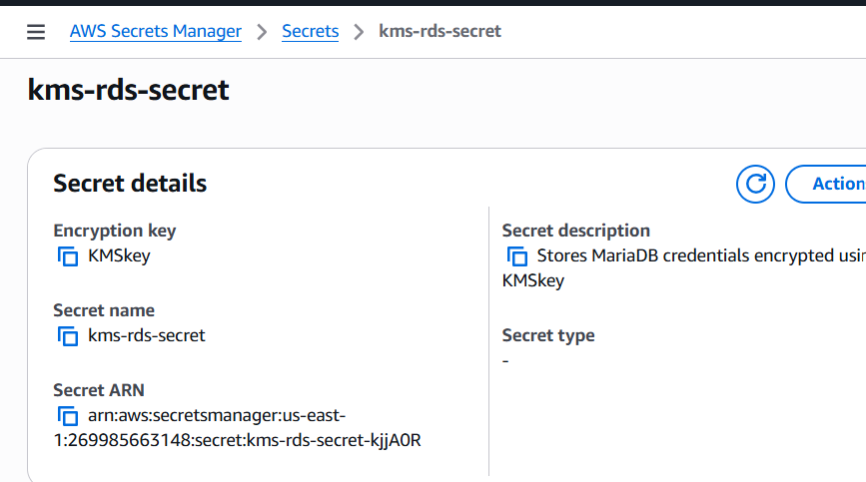

Part 5: Verify Systems Manager Parameter Store

Navigation
AWS Console
↓
Systems Manager
↓
Parameter Store

Procedure
- Open the parameter:
/database/password
- Open the parameter details.
Verify:
Property | Expected Value
Type | SecureString
KMS Key | KMSkey

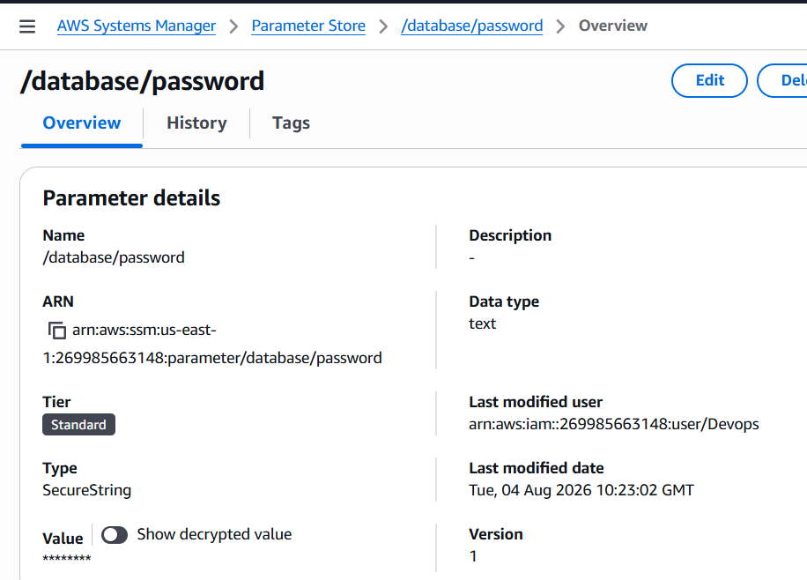

Final Verification Table
AWS Service | Encryption Enabled | KMS Key
Amazon S3 | ✅ Yes | ✅ KMSkey
Amazon EBS | ✅ Yes | ✅ KMSkey
Amazon RDS | ✅ Yes | ✅ KMSkey
Secrets Manager | ✅ Yes | ✅ KMSkey
Parameter Store | ✅ Yes | ✅ KMSkey

Why We Perform This Verification
Using the same Customer Managed KMS Key across multiple AWS services provides:
- Centralized encryption management.
- Consistent access control using IAM and KMS key policies.
- CloudTrail auditing of all key usage.
- Easier compliance and security management.
- Simplified key rotation and lifecycle management.

Expected Outcome
After completing this verification:
- ✅ S3 bucket is encrypted with KMSkey.
- ✅ EC2 EBS volume is encrypted with KMSkey.
- ✅ RDS database storage is encrypted with KMSkey.
- ✅ Secrets Manager secret is encrypted with KMSkey.
- ✅ Parameter Store SecureString is encrypted with KMSkey.
- ✅ A single Customer Managed KMS Key is successfully protecting multiple AWS services.

Task 3: Monitor and Use AWS KMS

Objective
Perform encryption/decryption operations and monitor KMS usage.

Activities
- Encrypt a file using the AWS CLI.
- Decrypt the encrypted file using the AWS CLI.
- Create an AWS Lambda function that uses KMS-encrypted environment variables.
- Enable AWS CloudTrail and verify KMS API events such as Encrypt, Decrypt, and GenerateDataKey.
- Validate that encryption and decryption work correctly across the integrated AWS services.

Prerequisites
- ✅ Customer Managed KMS Key (KMSkey) is in Enabled state.
- ✅ AWS CLI is installed and configured.
- ✅ IAM user has KMS, Lambda, and CloudTrail permissions.
- ✅ CloudTrail service is available.
- ✅ Region is the same as the KMS key (for example, us-east-1).

Step 1: Encrypt a File Using AWS CLI

Purpose
Encrypt a local file using your Customer Managed KMS Key (KMSkey). This demonstrates direct use of KMS for cryptographic operations.

Navigation
Local Computer / EC2 Instance
↓
Terminal
↓
AWS CLI

Detailed Procedure

1. Verify AWS CLI
Run:
aws --version
Example output:
aws-cli/2.x.x

2. Verify AWS Credentials
Run:
aws sts get-caller-identity
Expected output:
{
"UserId": "...",
"Account": "123456789012",
"Arn": "arn:aws:iam::123456789012:user/YourIAMUser"
}
This confirms you're using your IAM user.
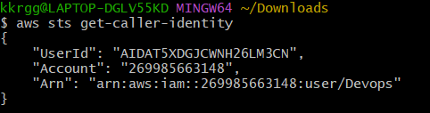

3. Create a Sample File
Create a file named sample.txt.
Linux/macOS:
echo "Hello AWS KMS" > sample.txt
Windows PowerShell:
"Hello AWS KMS" | Out-File sample.txt
Verify:
cat sample.txt
Output:
Hello AWS KMS
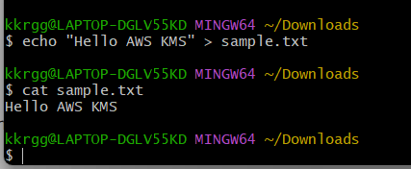

4. Find Your KMS Key ID
Run:
aws kms list-aliases
Find your alias:
alias/KMSkey
Replace KMSkey with your actual alias if it is different.
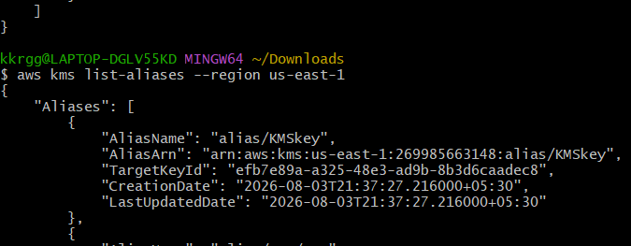

5. Encrypt the File
Run:
aws kms encrypt \
--key-id alias/KMSkey \
--plaintext fileb://sample.txt \
--output text \
--query CiphertextBlob > encrypted.txt
If you're using Windows Command Prompt, the command syntax is slightly different. Let me know if you're on Windows, Git Bash, PowerShell, or an EC2 Linux terminal.
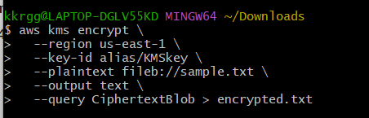

6. Verify the Encrypted File
Display the encrypted output:
cat encrypted.txt
You should see a long Base64-encoded string similar to:
AQICAHj............................................
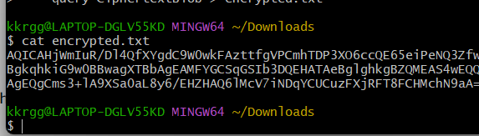

Why We Do This
This step demonstrates how AWS KMS encrypts data directly. The ciphertext can only be decrypted by someone with permission to use the same KMS key.

Expected Outcome
After completing this step:
- ✅ sample.txt contains the original plaintext.
- ✅ encrypted.txt contains the encrypted ciphertext.
- ✅ Encryption was performed using KMSkey.

Step 2: Decrypt the Encrypted File Using AWS CLI (Git Bash)

2.1 Decode the Base64 Ciphertext
Run:
tr -d '\r\n' < encrypted.txt > encrypted_singleline.txt
Then run:
base64 --decode encrypted_singleline.txt > encrypted.bin
Expected Outcome:
- encrypted_singleline.txt contains the Base64 ciphertext in a single line.
- encrypted.bin contains the binary ciphertext required by AWS KMS.
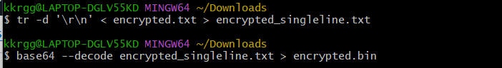

2.2 Decrypt the Binary Ciphertext
Run:
aws kms decrypt \
--region us-east-1 \
--ciphertext-blob fileb://encrypted.bin \
--query Plaintext \
--output text > decrypted.base64
Expected Outcome:
- decrypted.base64 contains the decrypted plaintext in Base64 format.
Example:
SGVsbG8gQVdTIEtNUwo=
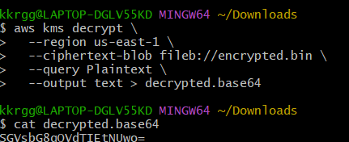

2.3 Decode the Plaintext
Run:
cat decrypted.base64 | tr -d '\r\n' | base64 --decode > decrypted.txt

2.4 Verify the Decrypted File
Run:
cat decrypted.txt
Expected output:
Hello AWS KMS
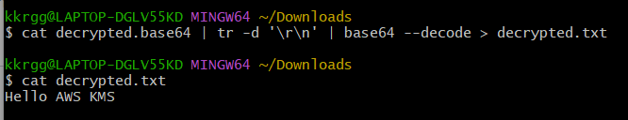

File Flow
sample.txt
│
▼
AWS KMS Encrypt
│
▼
encrypted.txt (Base64 ciphertext)
│
▼
base64 decode
│
▼
encrypted.bin
│
▼
AWS KMS Decrypt
│
▼
decrypted.base64
│
▼
base64 decode
│
▼
decrypted.txt

Expected Outcome
After completing Step 2:
- ✅ encrypted.txt contains encrypted ciphertext.
- ✅ encrypted.bin contains binary ciphertext.
- ✅ decrypted.base64 contains the decrypted plaintext encoded in Base64.
- ✅ decrypted.txt contains the original message:
Hello AWS KMS
- ✅ This proves that only someone with permission to use KMSkey can decrypt the data.

Step 3: Create an AWS Lambda Function That Uses KMS-Encrypted Environment Variables

Objective
Create a Lambda function and configure an environment variable that is encrypted using your Customer Managed KMS Key (KMSkey).

Why Are We Doing This?
Applications often need sensitive information like:
- Database passwords
- API keys
- Secret tokens
Instead of hardcoding them in the code, we store them as Lambda environment variables and encrypt them using AWS KMS.

Navigation
AWS Console
↓
Lambda
↓
Create Function

Step 1: Create the Lambda Function
- Open AWS Lambda.
- Click Create function.
Select:
Author from scratch

Configure Function
Setting | Value
Function name | KMS-Lambda
Runtime | Python 3.13 (or the latest available Python version)
Architecture | x86_64
Expand Change default execution role.
Select:
Create a new role with basic Lambda permissions
Click Create function.
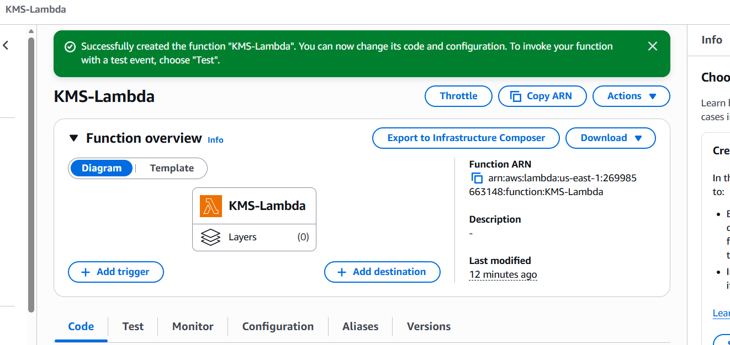

Step 2: Configure Environment Variables
Open:
Configuration
↓
Environment variables
Click:
Edit
Click:
Add environment variable
Enter:
Key | Value
DB_PASSWORD | MySecurePassword@123 (or the password you used for RDS)
Click:
Save
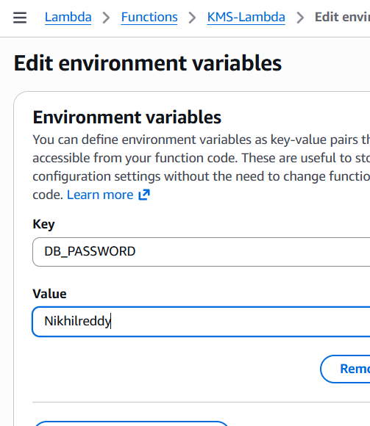

Step 3: Change the KMS Key
Still under Environment variables, locate:
Encryption configuration
By default, you'll see:
AWS managed key
Click:
Edit
Select:
Use a customer managed key
Choose:
KMSkey
(the Customer Managed KMS Key you created in Task 1)
Click:
Save
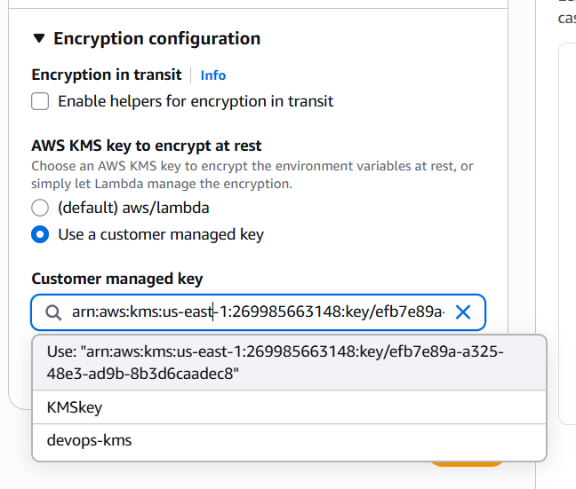

Step 4: Verify Encryption
Go back to:
Configuration
↓
Environment variables
Verify:
Property | Expected Value
Environment Variable | DB_PASSWORD
Encryption | Customer managed KMS key
KMS Key | KMSkey

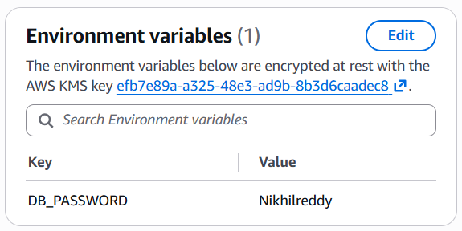

Step 5: Test the Lambda Function
Open:
Code
Replace the default code with:
import os

def lambda_handler(event, context):
password = os.environ.get("DB_PASSWORD")

return {
"statusCode": 200,
"body": f"Environment variable loaded successfully. Length: {len(password)}"
}
Click:
Deploy
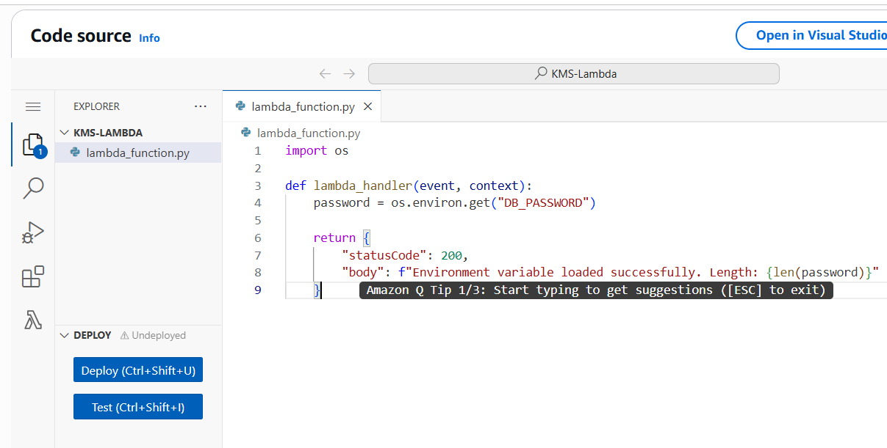

Step 6: Create a Test Event
Click:
Test
Configure:
Setting | Value
Event Name | KMSTest
Template | Hello World
Click:
Save
Then click:
Test
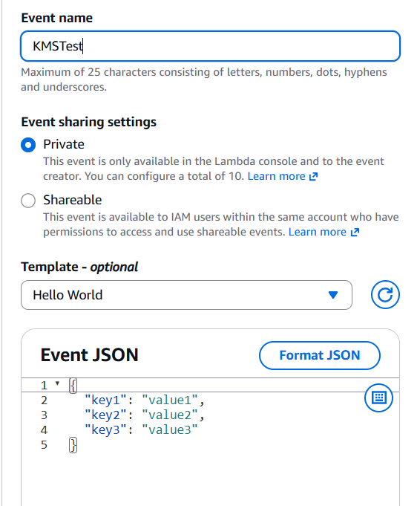

Expected Output
You should see something similar to:
{
"statusCode": 200,
"body": "Environment variable loaded successfully. Length: 19"
}
Note: The actual password is not displayed. The code only returns its length, demonstrating that Lambda could decrypt the environment variable using KMS.
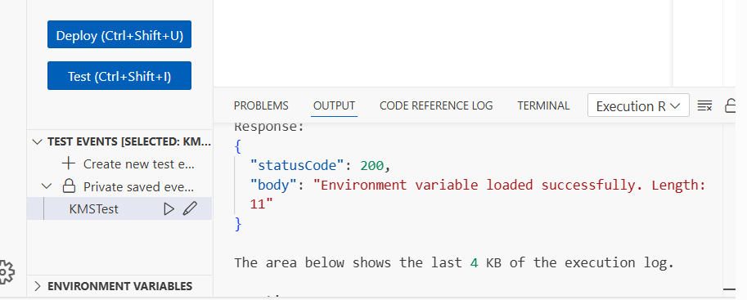

Why This Works
- You stored DB_PASSWORD as an environment variable.
- Lambda encrypted it using KMSkey.
- When the function ran, Lambda automatically decrypted it.
- Your code accessed the decrypted value through os.environ.

Expected Outcome
After completing Step 3:
- ✅ Lambda function created.
- ✅ Environment variable DB_PASSWORD added.
- ✅ Environment variable encrypted using KMSkey.
- ✅ Lambda successfully accessed the decrypted value during execution.

Step 4: Enable AWS CloudTrail and Verify KMS API Events

Objective
Enable AWS CloudTrail (if not already enabled) and verify that KMS API calls such as Encrypt, Decrypt, and GenerateDataKey are being logged.

Step 1: Open CloudTrail
Navigation:
AWS Console
↓
CloudTrail
↓
Trails

Step 2: Verify the Trail
You should see your existing trail.
Verify:
Property | Expected Value
Trail Status | Logging
Multi-region | Yes or No (either is fine for this lab)
Management Events | Enabled
If the trail status is Logging, proceed to the next step.
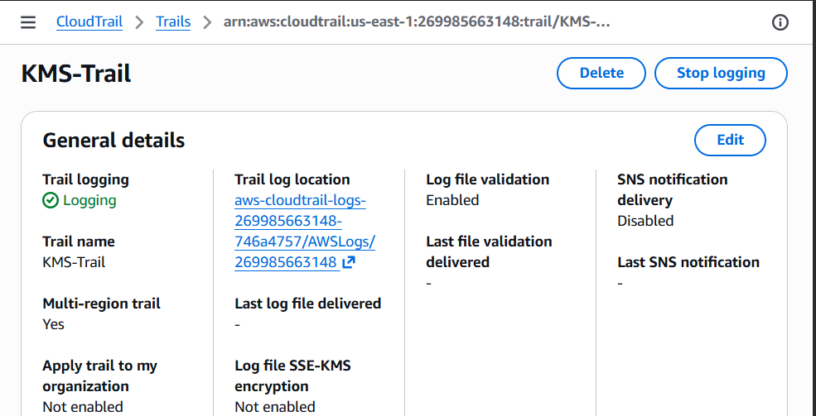

Step 3: Open Event History
Navigation:
CloudTrail
↓
Event history
This page displays recent AWS API calls.
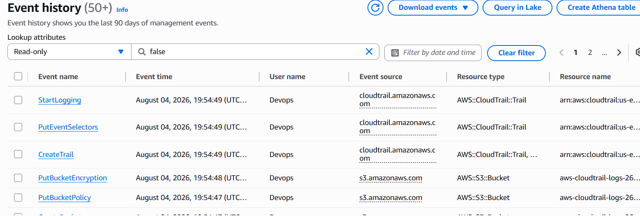

Step 4: Filter for KMS Events
At the top of the page:
- Filter by Event source.
- Enter:
kms.amazonaws.com
Alternatively, filter by Event name and search for:
- Encrypt
- Decrypt
- GenerateDataKey
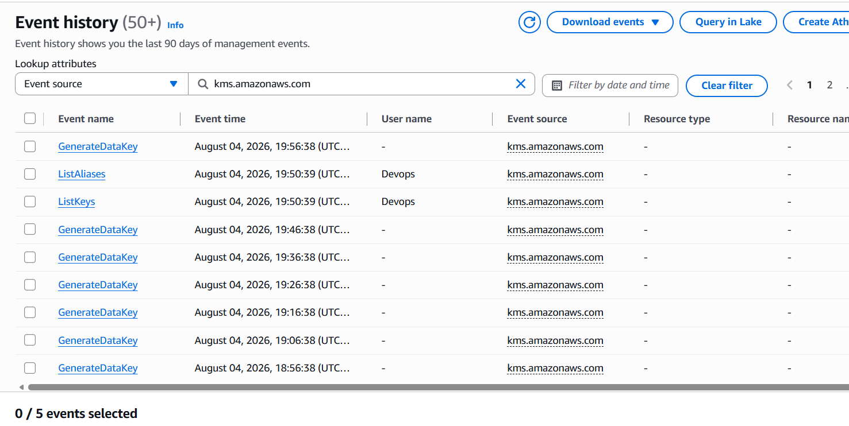
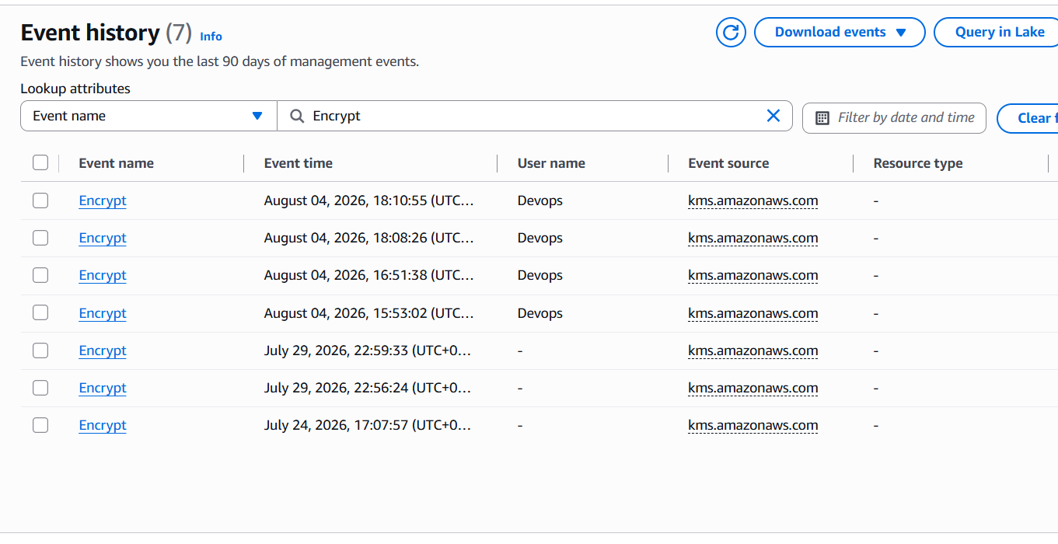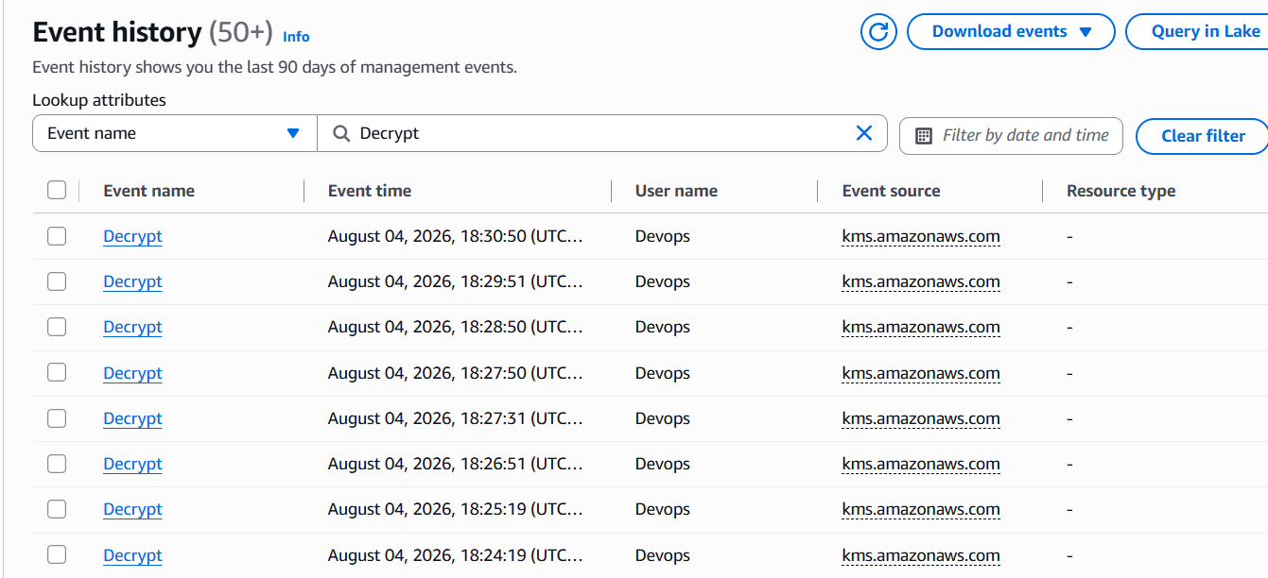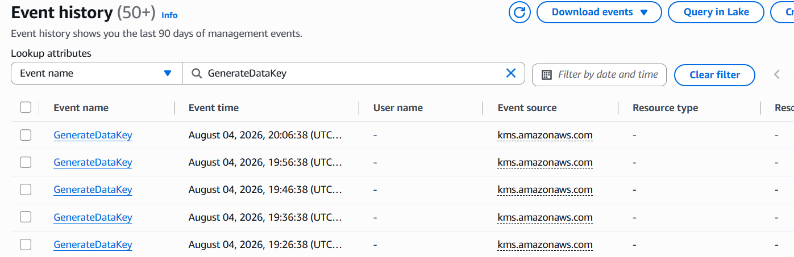

Step 5: Verify the Events
Since you already performed:
- Encrypt
- Decrypt
- Lambda environment variable encryption
You should see events similar to:
Event Name | Expected
Encrypt | ✅
Decrypt | ✅
GenerateDataKey | ✅ (may appear when AWS services such as Lambda, Secrets Manager, or SSM use KMS)
DescribeKey | Optional

Step 6: Open an Event
Click one Encrypt event.
Verify details such as:
Field | Expected Value
Event Source | kms.amazonaws.com
Event Name | Encrypt
Username | Your IAM user (Devops)
Region | us-east-1
Resource | KMSkey
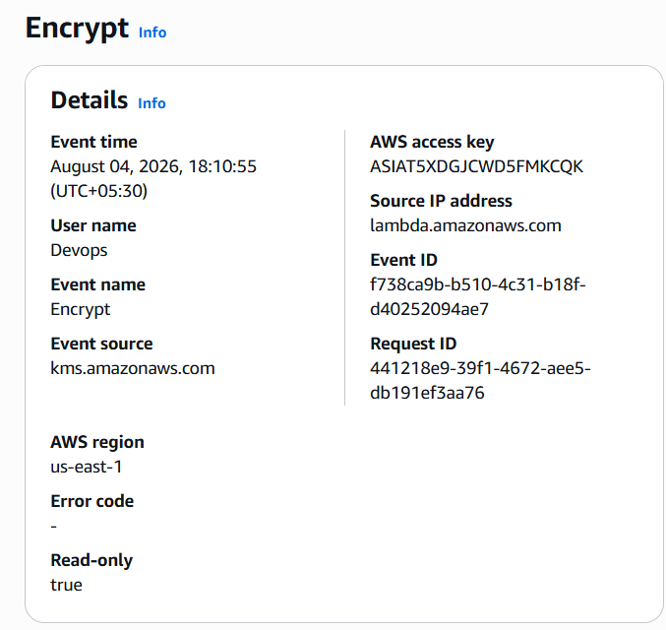

Step 7: Verify a Decrypt Event
Open one Decrypt event.
Verify:
- Event Source = kms.amazonaws.com
- Event Name = Decrypt
- User = Devops
- Resource = KMSkey
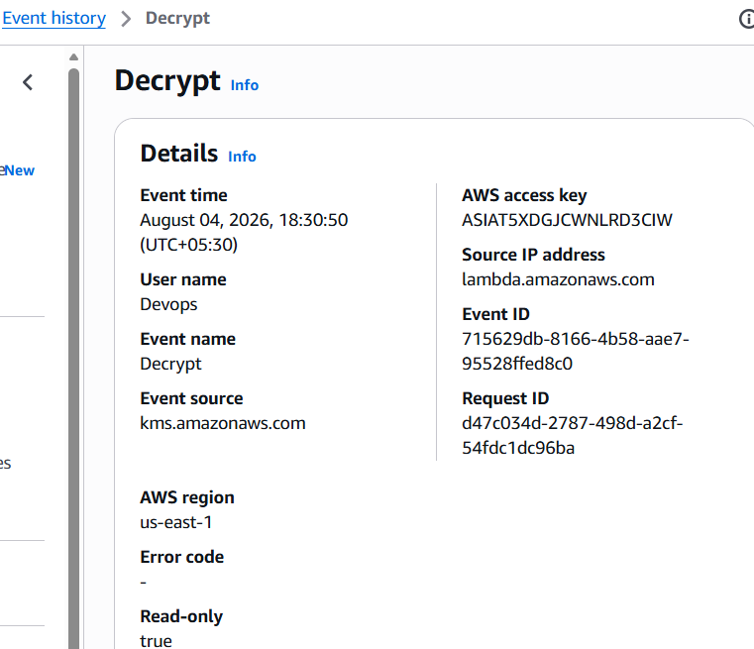

Step 8: Verify GenerateDataKey (if present)
If you configured:
- Lambda environment variables
- Secrets Manager
- Parameter Store
then you may also see:
GenerateDataKey
This is expected because these services use envelope encryption with KMS.
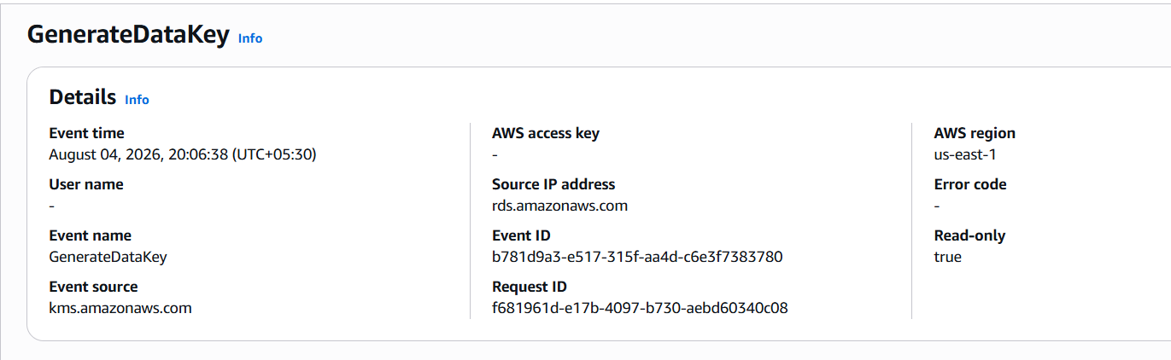

Expected Outcome
After completing Step 4:
- ✅ CloudTrail is logging AWS API calls.
- ✅ Encrypt event is visible.
- ✅ Decrypt event is visible.
- ✅ GenerateDataKey event is visible (if applicable).
- ✅ Events show your IAM user (Devops) and the KMS key being used.

Step 5: Validate Encryption and Decryption Across Integrated AWS Services

Objective
Verify that the AWS services configured in Task 2 are using your Customer Managed KMS Key (KMSkey) correctly.

Step 1: Verify S3 Bucket Encryption
Navigate to:
S3
↓
Your Bucket
↓
Properties
↓
Default encryption
Verify:
Property | Expected Value
Encryption Type | AWS KMS
KMS Key | KMSkey
Expected Outcome:
- ✅ Objects uploaded to the bucket are encrypted using KMSkey.
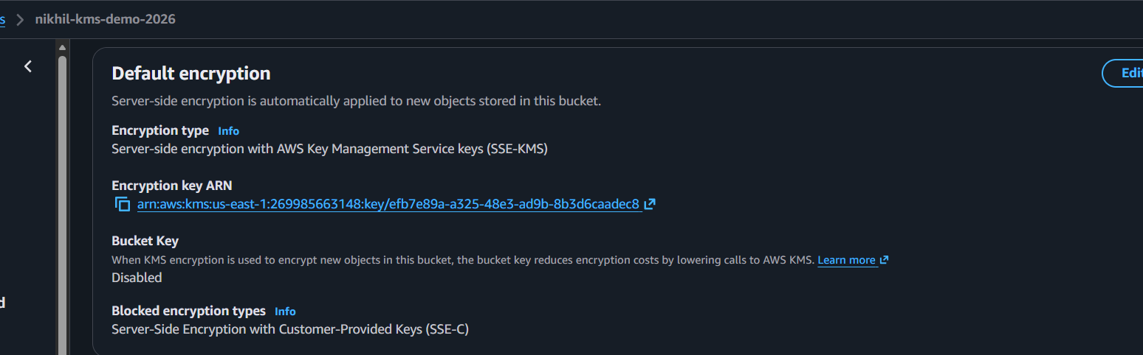

Step 2: Verify EBS Volume Encryption
Navigate to:
EC2
↓
Elastic Block Store
↓
Volumes
Select the volume attached to your EC2 instance.
Verify:
Property | Expected Value
Encryption | Enabled
KMS Key Alias | KMSkey
Expected Outcome:
- ✅ The EBS volume is encrypted using KMSkey.
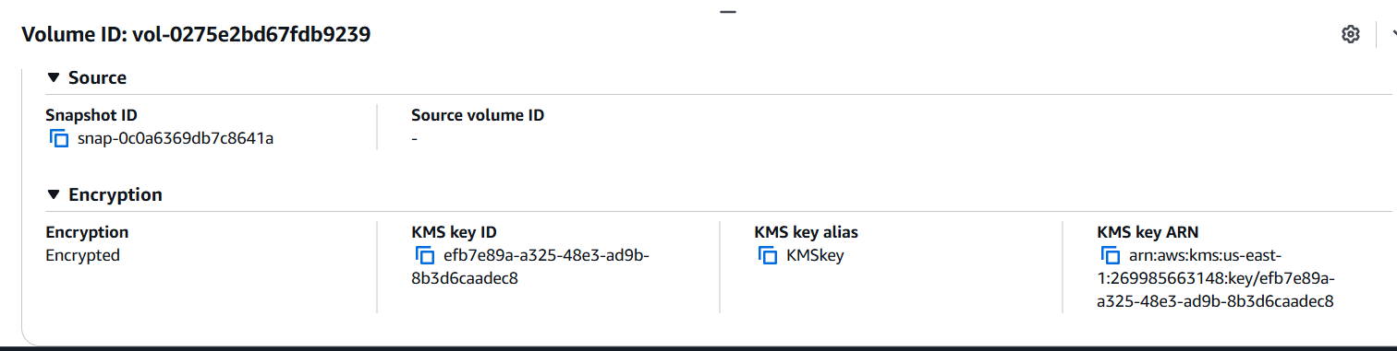

Step 3: Verify Secrets Manager
Navigate to:
Secrets Manager
↓
Secrets
↓
Your Secret
Verify:
Property | Expected Value
Encryption key | KMSkey
Click Retrieve secret value to confirm the secret can be decrypted.
Expected Outcome:
- ✅ The secret is stored encrypted with KMSkey.
- ✅ The secret value is retrieved successfully.
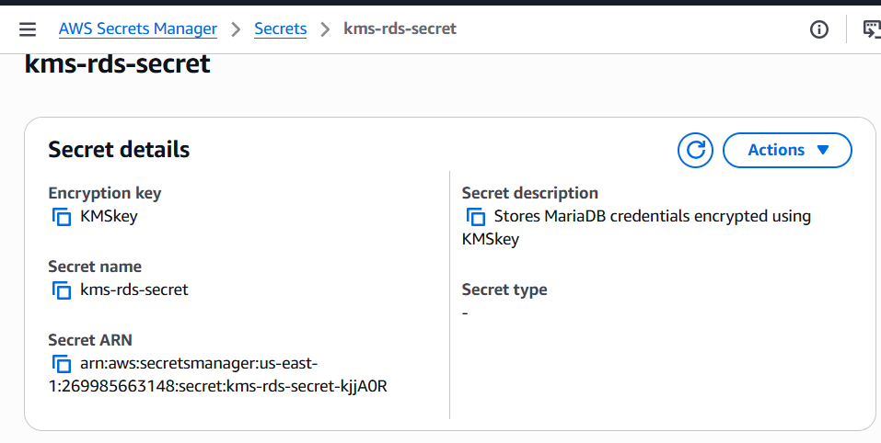

Step 4: Verify Systems Manager Parameter Store
Navigate to:
Systems Manager
↓
Parameter Store
↓
Your SecureString Parameter
Verify:
Property | Expected Value
Type | SecureString
KMS Key | KMSkey
Click the parameter and choose Show decrypted value (if available).
Expected Outcome:
- ✅ The parameter is encrypted with KMSkey.
- ✅ The value is successfully decrypted.
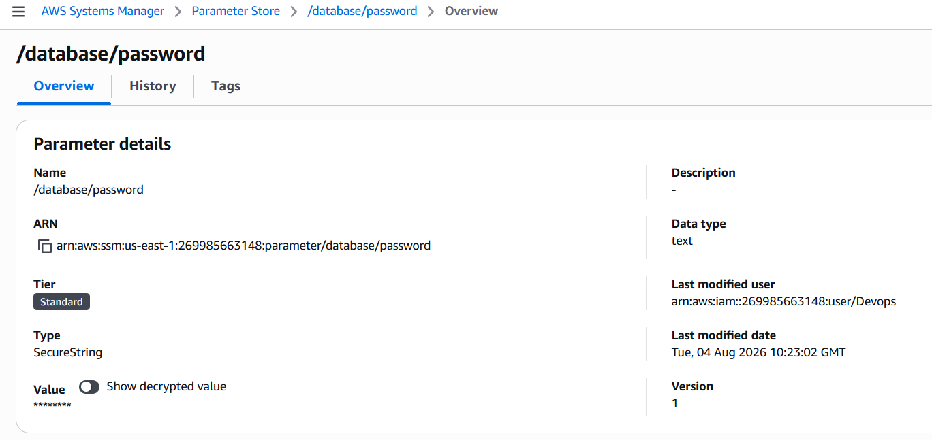

Step 5: Verify Lambda
Navigate to:
Lambda
↓
KMS-Lambda
↓
Configuration
↓
Environment Variables
Verify:
Property | Expected Value
Environment Variable | DB_PASSWORD
Encryption | Customer managed KMS key
KMS Key | KMSkey
Run a test invocation and confirm it succeeds.
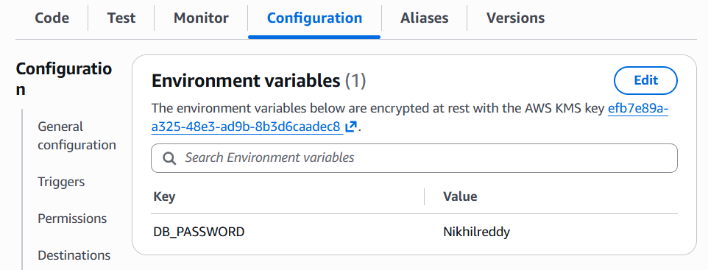

Step 6: Verify CloudTrail
Navigate to:
CloudTrail
↓
Event history
Filter by:
Event source = kms.amazonaws.com
Verify events such as:
- ✅ Encrypt
- ✅ Decrypt
- ✅ GenerateDataKey (if applicable)
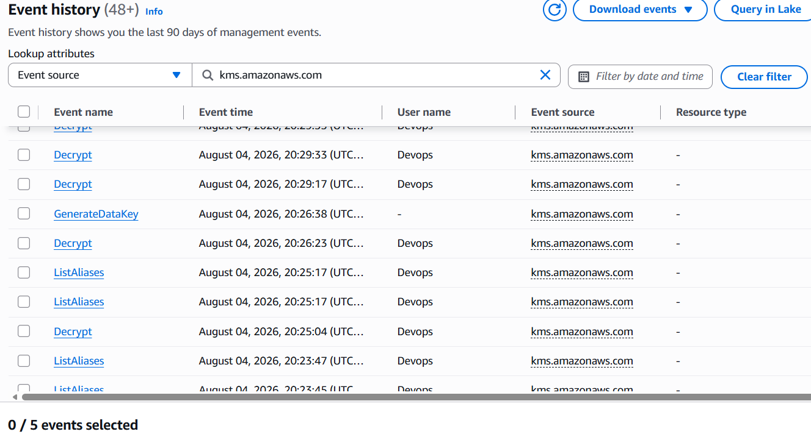
Expected Outcome:
- CloudTrail logs all KMS API operations.

Final Expected Outcome of Task 3
You have demonstrated that:
- ✅ Files can be encrypted and decrypted using AWS KMS.
- ✅ Lambda uses KMS-encrypted environment variables.
- ✅ S3 uses KMSkey for default encryption.
- ✅ EBS volume is encrypted with KMSkey.
- ✅ Secrets Manager stores secrets using KMSkey.
- ✅ Parameter Store stores SecureString values using KMSkey.
- ✅ CloudTrail records KMS API operations such as Encrypt, Decrypt, and GenerateDataKey

